Appendix A: Central Texts and Links

- “Water is Life” by Barbara Kingsolver http://ngm.nationalgeographic.com/2010/04/water-is-life/kingsolver-text
- Earth’s Water Cycle NASA Video http://svs.gsfc.nasa.gov/vis/a010000/a011000/a011054/index.html (video and transcript)
- The Earth as a System: Earth’s Spheres, Gallaudet University, (Slides 3-7): sci.gallaudet.edu/MSSDScience/ESSSpheres.ppt
- Relationship between the atmosphere, hydrosphere, lithosphere, and biosphere diagram: http://www.britannica.com/EBchecked/media/112176
- How Water Availability may change, as temperatures, population, and industrialization increase, 1961 – 1990. BBC News, December 2009: http://news.bbc.co.uk/2/hi/science/nature/7821082.stm
- Desertification Curriculum from United Nations Education, Scientific, and Cultural Organization: http://www.unesco.org/mab/doc/ekocd/index_case.html
- Climate and Water: In the Air and on Land, National Center for Atmospheric Research: https://spark.ucar.edu/longcontent/climate-and-water-air-and-land
- Blue Marble Globe Images and Animation Files, NASA: http://visibleearth.nasa.gov/view.php?id=57723
- Tropical Rainfall Measuring Mission – Middle School Overview. NASA: http://trmm.gsfc.nasa.gov/overview_dir/why-ms.html
- Water Cycle Model. United States Geologic Survey (USGS). http://ga.water.usgs.gov/edu/watercycle.html
- Water Cycle Model. Center for Atmospheric Research. https://www2.ucar.edu/atmosnews/people/aiguo-dai
- Water Cycle Model. Encyclopedia Britannica. http://www.britannica.com/EBchecked/topic/278858/hydrologic-cycle
- Water Cycle Model. U.S. Environmental Protection Agency.
http://www.epa.gov/climatechange/images/impacts-adaptation/WaterCycleChanges.jpg
- Water Cycle Model. BBC Education Scotland. http://www.bbc.co.uk/scotland/education/int/geog/rivers/hydrological.shtml
- Why Care About Water. National Geographic: http://video.nationalgeographic.com/video/environment/freshwater/env-freshwater-whycare/

“Water is Life” by Barbara Kingsolver (April 2010, National Geographic Magazine)
http://ngm.nationalgeographic.com/2010/04/water-is-life/kingsolver-text

Student Text with Glossary (Lessons 1-8)

Text  This is Barbara Kingsolver’s article “Water is Life” reformatted for you to use during Lessons 1 -8. Paragraphs are numbers and divided to align with the lessons. | Glossary  Below are simple definitions of words that will be difficult for you to figure out using context clues. Some of these words will be explained before you read and some of these words are here so you can access the definition while you read.
Fresh Water  The amount of moisture on Earth has not changed. The water the dinosaurs drank millions of years ago is the same water that falls as rain today. But will there be enough for a more crowded world? | Academic Vocabulary  Science Vocabulary  - fresh water - water that contains less than 0.2 percent dissolved salts
Para 1.We keep an eye out for wonders, my daughter and I, every morning as we walk down our farm lane to meet the school bus. And wherever we find them, they reflect the magic of water: a spider web drooping with dew like a rhinestone necklace. A rain-colored heron rising from the creek bank. One astonishing morning, we had a visitation of frogs. Dozens of them hurtled up from the grass ahead of our feet, launching themselves, white-bellied, in bouncing arcs, as if we'd been caught in a downpour of amphibians. It seemed to mark the dawning of some new aqueous age. On another day we met a snapping turtle in his primordial olive drab armor. Normally this is a pond-locked creature, but some murky ambition had moved him onto our gravel lane, using the rainy week as a passport from our farm to somewhere else. | Academic Vocabulary  - hurtle - race through the air  - arcs - arch  - primordial - prehistoric  - murky - unknown  - ambition - desire  - drab - dull  - passport - ticket  Science Vocabulary  - aqueous - related to water
Para 2: The little, nameless creek tumbling through our hollow holds us in thrall. Before we came to southern Appalachia, we lived for years in Arizona, where a permanent runnel of that size would merit a nature preserve. In the Grand Canyon State, every license plate reminded us that water changes the face of the land, splitting open rock desert like a peach, leaving mile-deep gashes of infinite hue. Cities there function like space stations, importing every ounce of fresh water from distant rivers or fossil aquifers. But such is the human inclination to take water as a birthright that public fountains still may bubble in Arizona's town squares and farmers there raise thirsty crops. Retirees from rainier climes irrigate green lawns that impersonate the grasslands they left behind. The truth encroaches on all the fantasies, though, when desert residents wait months between rains, watching cacti tighten their belts and roadrunners skirmish over precious beads from a dripping garden faucet. Water is life. It's the briny broth of our origins, the pounding circulatory system of the world, a precarious molecular edge on which we survive. It makes up two-thirds of our bodies, just like the map of the world; our vital fluids are saline, like the ocean. The apple doesn't fall far from the tree. | Academic Vocabulary  - thrall - a state of complete absorption  - impersonate - pretend to be  - inclination - tendency  - brine - saltwater  - merit - call for  - nature preserve - protected natural area  - importing - bringing in  - infinite - countless  - hue - color  - encroach - intrude  - cacti - more than one cactus  - roadrunner - fast-running desert bird  - skirmish - fight  - precarious - unstable  Science Vocabulary  - saline - salty  - aquifer - water-bearing rock  - irrigate - flood with water  - clime - climate
Para 3. Even while we take Mother Water for granted, humans understand in our bones that she is the boss. We stake our civilizations on the coasts and mighty rivers. Our deepest dread is the threat of having too little moisture—or too much. We've lately raised the Earth's average temperature by .74°C (1.3°F), a number that sounds inconsequential. But these words do not: flood, drought, hurricane, rising sea levels, bursting levees. Water is the visible face of climate and, therefore, climate change. Shifting rain patterns flood some regions and dry up others as nature demonstrates a grave physics lesson: Hot air holds more water molecules than cold. | Academic Vocabulary  - civilization - society  - coast - shoreline  - inconsequential - unimportant  - levee - protective wall  - grave - serious  Science Vocabulary  - flood - water covering previously dry area  - drought - lack of water  - hurricane - severe storm with high wind  - climate - typical weather over a period of time  - physics - study of physical forces
Para 4. The results are in plain sight along pummeled coasts from Louisiana to the Philippines as super warmed air above the ocean brews superstorms, the likes of which we have never known. In arid places the same physics amplify evaporation and drought, visible in the dust-dry farms of the Murray-Darling River Basin in Australia. On top of the Himalaya, glaciers whose meltwater sustains vast populations are dwindling. The snapping turtle I met on my lane may have been looking for higher ground. Last summer brought us a string of floods that left tomatoes blighted on the vine and our farmers needing disaster relief for the third consecutive year. The past decade has brought us more extreme storms than ever before, of the kind that dump many inches in a day, laying down crops and utility poles and great sodden oaks whose roots cannot find purchase in the saturated ground. The word "disaster" seems to mock us. After enough repetitions of shocking weather, we can't remain indefinitely shocked.  Para 5. How can the world shift beneath our feet? All we know is founded on its rhythms: Water will flow from the snowcapped mountains, rain and sun will arrive in their proper seasons. Humans first formed our tongues around language, surely, for the purpose of explaining these constants to our children. What should we tell them now? That "reliable" has been rained out, or died of thirst? When the Earth seems to raise its own voice to the pitch of a gale, have we the ears to listen? | Academic Vocabulary  - pummel - beat up  - brew - develops  - amplify - strengthen  - sustain - support  - vast - huge  - dwindling - decreasing  - string (of floods) - series  - blighted - ruined  - decade - span of 10 years  - laying down - flattening  - mock - make fun of  - repetitions - repeated occurrences  - rhythms - patterns  - constants - consistencies  Science Vocabulary  - evaporation - the process of liquid becoming vapor  - drought - period of dry weather  - glaciers - ice masses  - meltwater - melted ice and snow  - floods - water covering previously dry area  - storm - violent weather  - arid - dry, waterless  - saturated- full of liquid  - weather - state of atmosphere  - flow - move freely  Places on a map  Murray Darling River Basin  Himalaya

Para 6. A world away from my damp hollow, the Bajo Piura Valley is a great bowl of the driest Holocene sands I've ever gotten in my shoes. Stretching from coastal, northwestern Peru into southern Ecuador, the 14,000-square-mile Piura Desert is home to many endemic forms of thorny life. Profiles of this eco-region describe it as dry to drier, and Bajo Piura on its southern edge is what anyone would call driest. Between January and March it might get close to an inch of rain, depending on the whims of El Niño, my driver explained as we bumped over the dry bed of the Rïo Piura, "but in some years, nothing at all." For hours we passed through white-crusted fields ruined by years of irrigation and then into eye-burning valleys beyond the limits of endurance for anything but sparse stands of the deep-rooted Prosopis pallida, arguably nature's most arid-adapted tree. And remarkably, some scattered families of Homo sapiens.  Para 7. They are economic refugees, looking for land that costs nothing. In Bajo Piura they find it, although living there has other costs, and fragile drylands pay their own price too, as people exacerbate desertification by cutting anything living for firewood. What brought me there, as a journalist, was an innovative reforestation project. Peruvian conservationists, partnered with the NGO Heifer International, were guiding the population into herding goats, which eat the protein-rich pods of the native mesquite and disperse its seeds over the desert. In the shade of a stick shelter, a young mother set her dented pot on a dung-fed fire and showed how she curdles goat's milk into white cheese. But milking goats is hard to work into her schedule when she, and every other woman she knows, must walk about eight hours a day to collect water.  Para 8. Their husbands were digging a well nearby. They worked with hand trowels, a plywood form for lining the shaft with concrete, inch by inch, and a sturdy hand-built crank for lowering a man to the bottom and sending up buckets of sand. A dozen hopeful men in stained straw hats stood back to let me inspect their work, which so far had yielded only a mountain of exhumed sand, dry as dust. I looked down that black hole, then turned and climbed the sand mound to hide my unprofessional tears. I could not fathom this kind of perseverance and wondered how long these beleaguered people would last before they'd had enough of their water woes and moved somewhere else.  Para 9. Five years later they are still bringing up dry sand, scratching out their fate as a microcosm of life on this planet. There is nowhere else. Forty percent of the households in sub-Saharan Africa are more than a half hour from the nearest water, and that distance is growing. Australian farmers can't follow the rainfall patterns that have shifted south to fall on the sea. A salmon that runs into a dam when homing in on her natal stream cannot make other plans. Together we dig in, for all we're worth. | Academic Vocabulary  - hollow - valley  - coastal - next to the sea  - endemic - widespread  - endurance - ability to bear hardship  - sparse - thin  - refugee - someone seeking a safe place  - fragile - easily broken  - conservationist - supporter of protecting the environment  - NGO - nongovernmental organization  - Heifer International - a nonprofit organization with the goal of ending poverty and hunger  - dung - animal waste; manure  - trowel - short-handled gardener’s tool  - fathom - understand  - beleaguered - struggling  - microcosm - small version of something larger  Science Vocabulary  - El Nino - band of unusually warm ocean water temperatures in South America which can cause climactic changes across the Pacific Ocean  - Holocene - most recent geologic period  - dry bed - riverbed that contains water only during times of heavy rain  - irrigation - system to supply an area with water  - Prosopis Pallida - a species of mesquite tree  - Homo Sapiens - humans  - desertification - process of becoming desert  - reforestation - act of replanting an area with trees  - mesquite - small, spiny tree  - well - hole made to draw up fluids  - natal stream - stream of birth  - dam - barrier controlling flow of water  Places on a map  Bajo Piura  Puru  Ecuador  Piura Desert  Sub-Saharan Africa  Australia

Para 10. Since childhood I’ve heard it’s possible to look up from the bottom of a well and see stars, even in daylight. Aristotle wrote about this, and so did Charles Dickens. On many a dark night the vision of that round slip of sky with stars has comforted me. Here’s the only problem: It’s not true. Western civilization was in no great hurry to give up this folklore; astronomers believed it for centuries, but a few of them eventually thought to test it and had their illusions dashed by simple observation.  Para 11. Civilization has been similarly slow to give up on our myth of the Earth’s infinite generosity. Declining to look for evidence to the contrary, we just knew it was there. We pumped aquifers and diverted rivers, trusting the twin lucky stars of unrestrained human expansion and endless supply. Now water tables plummet in countries harboring half the world’s population. Rather grandly, we have overdrawn our accounts. | Historic Figures  - Aristotle - Greek philosopher known as the “father of science”  - Charles Dickens - English author and social critic from the 1800’s  Academic Vocabulary  - slip - narrow piece  - astronomers - space scientists  - century - 100-year period  - illusions - false ideas  - generosity - kindness  - declining - refusing  - unrestrained - unrestricted  - expansion - growth  - harboring - sheltering  - overdrawn - overspent  - diverted - redirected  Science Vocabulary

Para 12. In 1968 the ecologist Garrett Hardin wrote a paper called “The Tragedy of the Commons,” required reading for biology students ever since. It addresses the problems that can be solved only by “a change in human values or ideas of morality” in situations where rational pursuit of individual self-interest leads to collective ruin. Cattle farmers who share a common pasture, for example, will increase their herds one by one until they destroy the pasture by overgrazing. Agreeing to self-imposed limits instead, unthinkable at first, will become the right thing to do. While our laws imply that morality is fixed, Hardin made the point that “the morality of an act is a function of the state of the system at the time it is performed.” Surely it was no sin, once upon a time, to shoot and make pies of passenger pigeons.  Para 13. Water is the ultimate commons. Watercourses once seemed as boundless as those pigeons that darkened the sky overhead, and the notion of protecting water was as silly as bottling it. But rules change. Time and again, from New Mexico’s antique irrigation codes to the UN Convention on International Watercourses, communities have studied water systems and redefined wise use. Now Ecuador has become the first nation on Earth to put the rights of nature in its constitution so that rivers and forests are not simply property but maintain their own right to flourish. Under these laws a citizen might file suit on behalf of an injured watershed, recognizing that its health is crucial to the common good. Other nations may follow Ecuador’s lead. Just as legal systems once reeled to comprehend women or former slaves as fully entitled, law schools in the U.S. are now reforming their curricula with an eye to understanding and acknowledging nature’s rights.  Para 14. On my desk, a glass of water has caught the afternoon light, and I'm still looking for wonders. Who owns this water? How can I call it mine when its fate is to run through rivers and living bodies, so many already and so many more to come? It is an ancient, dazzling relic, temporarily quarantined here in my glass, waiting to return to its kind, waiting to move a mountain. It is the gold standard of biological currency, and the good news is that we can conserve it in countless ways. Also, unlike petroleum, water will always be with us. Our trust in Earth's infinite generosity was half right, as every raindrop will run to the ocean, and the ocean will rise into the firmament. And half wrong, because we are not important to water. It's the other way around. Our task is to work out reasonable ways to survive inside its boundaries. We'd be wise to fix our sights on some new stars. The gentle nudge of evidence, the guidance of science, and a heart for protecting the commons: These are the tools of a new century. Taking a wide-eyed look at a watery planet is our way of knowing the stakes, the better to know our place. | Academic Vocabulary  - morality - goodness  - rational - sensible  - pursuit - search  - self-interest - self-centeredness  - collective - shared  - pasture - meadow  - overgrazing - animal consumption of plants that is not sustainable  - self-imposed - voluntary  - function - result  - state - condition  - passenger pigeons - extinct North American bird  - boundless - endless  - redefined - changed  - flourish - succeed  - suit - legal proceeding  - reel - be astounded  - comprehend - understand  - acknowledge - recognize  - fate - destiny  - dazzling - amazing  - relic - historical object  - gold standard - best  - currency - money  - conserve - preserve  - petroleum - fuel  - firmament - sky  - boundaries - limits  - evidence - proof  - guidance - direction  - commons - shared area  - stakes - dangers  Science Vocabulary  - Watercourse - channel for flowing water  - Watershed - region draining into a river or ocean  - UN Convention on International Watercourse - document adopted by the United Nations to help conserve and manage water resources for present and future generations

Appendix B: Handouts and Recording Forms

Lesson 1 - “Water is Life” Text Analysis (Teacher Reference)

Introduction: Personal Connections | Para 1.We keep an eye out for wonders, my daughter and I, every morning as we walk down our farm lane to meet the school bus. And wherever we find them, they reflect the magic of water: a spider web drooping with dew like a rhinestone necklace. A rain-colored heron rising from the creek bank. One astonishing morning, we had a visitation of frogs. Dozens of them hurtled up from the grass ahead of our feet, launching themselves, white-bellied, in bouncing arcs, as if we'd been caught in a downpour of amphibians. It seemed to mark the dawning of some new aqueous age. On another day we met a snapping turtle in his primordial olive drab armor. Normally this is a pond-locked creature, but some murky ambition had moved him onto our gravel lane, using the rainy week as a passport from our farm to somewhere else.  Text Dependent Questions:  - In paragraph 1, Kingsolver says that she and her daughter “keep an eye out for wonders” as they walk from their farmhouse each day. Underline in the text the four specific wonders they see. {spider web, heron, frogs, turtle}  - Kingsolver uses really powerful descriptive language. For each of the wonders you underlined, what is the picture you see in your head? Describe it.  - What does the word “aqueous” mean? How does this word relate to the animals Kingsolver describes?  - Based on her description, what assumptions can you make about the relationship Kingsolver and her daughter have with water? | Unit vocabulary: NONE  Vocab Defined by teacher  Hurtle  Arcs  Primordial  Murky  Ambition  Drab  Passport  Vocab for student to determine meaning in context:  Dew  amphibian  Heron  Creek  Unit Vocab in text dependent questions:  aqueous
Thesis – Part 1 | Para 2: The little, nameless creek tumbling through our hollow holds us in thrall. Before we came to southern Appalachia, we lived for years in Arizona, where a permanent runnel of that size would merit a nature preserve. In the Grand Canyon State, every license plate reminded us that water changes the face of the land, splitting open rock desert like a peach, leaving mile-deep gashes of infinite hue. Cities there function like space stations, importing every ounce of fresh water from distant rivers or fossil aquifers. But such is the human inclination to take water as a birthright that public fountains still may bubble in Arizona's town squares and farmers there raise thirsty crops. Retirees from rainier climes irrigate green lawns that impersonate the grasslands they left behind. The truth encroaches on all the fantasies, though, when desert residents wait months between rains, watching cacti tighten their belts and roadrunners skirmish over precious beads from a dripping garden faucet. Water is life. It's the briny broth of our origins, the pounding circulatory system of the world, a precarious molecular edge on which we survive. It makes up two-thirds of our bodies, just like the map of the world; our vital fluids are saline, like the ocean. The apple doesn't fall far from the tree.  Text Dependent Questions:  - When Kingsolver describes how “water changes the face of the land”, what is she talking about? What famous landmark is she describing? (Erosion – add this to interactive word wall.  - Near the end of paragraph 2, Kingsolver writes a very short sentence, which is also the title of the article: “Water is life.” What does she mean? What evidence does she cite in this paragraph to support this claim?  - Kingsolver mentions different types of fluid is this paragraph – can you identify them? (fresh water, brine, vital fluids) Why are they important?  SCIENCE NOTES: From ancient times, explorers have "followed the water." Water's unique chemical and physical properties are essential to human survival. Without water, basic physical processes would be impossible. Cells within the human body would die. None of the essential physical functions, such as breathing, digestion, or muscle movement could take place without water.  About 70 percent of the human body is made up of water and, coincidentally, more than 70 percent of Earth is covered in water. Water creates an environment that sustains and nurtures plants, animals and humans, making Earth a perfect match for life in general. | Unit Vocab:  Fresh water  saline  Aquifers  Irrigate  Climes  Vacab. Defined by Teacher:  Thrall  Impersonate  Inclination  Brine  Merit  Nature Preserve  Importing  Infinite  Hue  Encroach  Cati  Roadrunner  Skirmish  precarious  Places on a Map:  Southern Appalacia  Grand Canyon  Vocab determined by students:  Runnel  Hollow  Retirees  Desert residents  Birthright  Unit Vocabulary in TDQ:  Science Vocab  Creek  Runnel  desert  Erosion  Fresh water  Vital fluids
Thesis Part II | Para 3. Even while we take Mother Water for granted, humans understand in our bones that she is the boss. We stake our civilizations on the coasts and mighty rivers. Our deepest dread is the threat of having too little moisture—or too much. We've lately raised the Earth's average temperature by .74°C (1.3°F), a number that sounds inconsequential. But these words do not: flood, drought, hurricane, rising sea levels, bursting levees. Water is the visible face of climate and, therefore, climate change. Shifting rain patterns flood some regions and dry up others as nature demonstrates a grave physics lesson: Hot air holds more water molecules than cold.  - Kingsolver writes that “humans understand in our bones that she is the boss”? Who is ‘she’ and why does Kingsolver say ‘she’ is the boss?  - Why is Kingsolver so concerned about flood, drought, hurricane, rising sea levels, bursting levees?  - What does Kingsolver mean by “grave physics lesson?” How does this relate to the next sentence “hot air hold more water molecules than cold.” How can air hold water?  SCIENCE NOTES: The physical properties of water is the BIG science concept here. Students need to be taught that the three properties of water determine how much fresh water is available for human consumption and where that water falls is dependent upon temperature!  Properties of water:  Solid (Fresh water is held in Ice Caps, Snow, Glaciers)  Gas: When water warms, it evaporates…turns into vapor and eventually moves through the atmosphere as hydrogen and oxygen. Evaporation, evapotranspiration, transpiration – are the ways that water vapor gets into the air. All of these processes create “pure” fresh water. As water evaporates, all of the impurities that are in the fresh water (or salt water), are left in the streams, wetlands, rivers, and oceans as water evaporates)  Liquid: The molecules (Hydrogen and Oxygen) in water vapor also move more quickly so they can stay suspended in air. As the air cools, the molecules slow and fall to the ground as liquids (rain) or solids (snow, sleet, hail) the temperature of the air determines the form that the molecules fall. Liquid also can seep and infiltrate into the earth. This is how water gets into the aquifers. Aquifers allow fresh water to flow underground without evaporating. | Unit Vocab:  Flood  Drought  Hurricane  Climate  Physics  Academic Vocab:  Civilization  Coasts  Inconsequential  Levee  Grave  Context Vocab:  Vapor

Water Cycle – The Science | SCIENCE NOTE: Before reading this paragraph has student highlight all of the words related to water. It is at this point in the article that Kingsolver has introduces most, if not all, of the big chunks of the hydrosphere (Evaporation, Groundwater-Aquifers, streams & rivers, oceans and reservoirs) Add all words to the word wall and see if they are able to make the connection between the properties (solid, liquid, gas) and the movement of water). Make sure that all students understand these vocabulary words at the end of these two lessons. The remainder of the module is dependent upon this foundation.  Para 4. The results are in plain sight along pummeled coasts from Louisiana to the Philippines as super warmed air above the ocean brews superstorms, the likes of which we have never known. In arid places the same physics amplify evaporation and drought, visible in the dust-dry farms of the Murray-Darling River Basin in Australia. On top of the Himalaya, glaciers whose meltwater sustains vast populations are dwindling. The snapping turtle I met on my lane may have been looking for higher ground. Last summer brought us a string of floods that left tomatoes blighted on the vine and our farmers needing disaster relief for the third consecutive year. The past decade has brought us more extreme storms than ever before, of the kind that dump many inches in a day, laying down crops and utility poles and great sodden oaks whose roots cannot find purchase in the saturated ground. The word "disaster" seems to mock us. After enough repetitions of shocking weather, we can't remain indefinitely shocked.  Para 5. How can the world shift beneath our feet? All we know is founded on its rhythms: Water will flow from the snowcapped mountains, rain and sun will arrive in their proper seasons. Humans first formed our tongues around language, surely, for the purpose of explaining these constants to our children. What should we tell them now? That "reliable" has been rained out, or died of thirst? When the Earth seems to raise its own voice to the pitch of a gale, have we the ears to listen?  Text Dependent Questions:  - In paragraph 4, Kingsolver writes “The past decade has brought us more extreme storms than ever before.” What evidence does she cite to support this claim?  - In paragraph five, Kingsolver uses the phrase, “water will flow from snowcapped mountains, rain and sun will arrive in their proper seasons.” to describe how we understand water. Does Kingsolver still believe this? What phrases or questions does she use to support her beliefs? | Unit Vocab:  Academic Vocab  Pummeled  Brew  Amplify  Sustain  Vast  Dwindling  String of floods  Blighted  Decade  Laying down crops  Mock  Repetition  Rhythms  constants  Science Vocab:  evaporation  drought  Glaciers  Melt water  Floods  Storms  Arid  Saturated ground  Weather  Flow
 | SCIENCE NOTES: After reading this section, pull all of the vocabulary together by using the interactive word wall to create your first model (flow chart if you will) of the properties and movement of water through the hydrosphere. Rewatch the NASA video that we used in Lesson 1 of Unit 1 and then create a water cycle using the vocabulary from the Interactive Word Wall. Fill in vocabulary as it is identified by the students.  TDQ after Interactive Word Wall:  - In paragraph 2, the final sentence, Kingsolver uses the phrase pounding circulatory system of the world, how does this relate to what you now know about the properties and movement of water in the hydrosphere? | Places on a map: Murray Darling River Basin  Himalaya

The Evidence: Desertification and Extreme Weather Events | Para 6. A world away from my damp hollow, the Bajo Piura Valley is a great bowl of the driest Holocene sands I've ever gotten in my shoes. Stretching from coastal, northwestern Peru into southern Ecuador, the 14,000-square-mile Piura Desert is home to many endemic forms of thorny life. Profiles of this eco-region describe it as dry to drier, and Bajo Piura on its southern edge is what anyone would call driest. Between January and March it might get close to an inch of rain, depending on the whims of El Niño, my driver explained as we bumped over the dry bed of the Rïo Piura, "but in some years, nothing at all." For hours we passed through white-crusted fields ruined by years of irrigation and then into eye-burning valleys beyond the limits of endurance for anything but sparse stands of the deep-rooted Prosopis pallida, arguably nature's most arid-adapted tree. And remarkably, some scattered families of Homo sapiens.  Para 7. They are economic refugees, looking for land that costs nothing. In Bajo Piura they find it, although living there has other costs, and fragile drylands pay their own price too, as people exacerbate desertification by cutting anything living for firewood. What brought me there, as a journalist, was an innovative reforestation project. Peruvian conservationists, partnered with the NGO Heifer International, were guiding the population into herding goats, which eat the protein-rich pods of the native mesquite and disperse its seeds over the desert. In the shade of a stick shelter, a young mother set her dented pot on a dung-fed fire and showed how she curdles goat's milk into white cheese. But milking goats is hard to work into her schedule when she, and every other woman she knows, must walk about eight hours a day to collect water.  Para 8. Their husbands were digging a well nearby. They worked with hand trowels, a plywood form for lining the shaft with concrete, inch by inch, and a sturdy hand-built crank for lowering a man to the bottom and sending up buckets of sand. A dozen hopeful men in stained straw hats stood back to let me inspect their work, which so far had yielded only a mountain of exhumed sand, dry as dust. I looked down that black hole, then turned and climbed the sand mound to hide my unprofessional tears. I could not fathom this kind of perseverance and wondered how long these beleaguered people would last before they'd had enough of their water woes and moved somewhere else.  Para 9. Five years later they are still bringing up dry sand, scratching out their fate as a microcosm of life on this planet. There is nowhere else. Forty percent of the households in sub-Saharan Africa are more than a half hour from the nearest water, and that distance is growing. Australian farmers can't follow the rainfall patterns that have shifted south to fall on the sea. A salmon that runs into a dam when homing in on her natal stream cannot make other plans. Together we dig in, for all we're worth.  Text Dependent Questions  - In paragraphs 6, 7, and 8, Kingsolver describes one example of people living in the Piura Desert in order to show what it is like to live in an area of extreme drought. Underline in the text examples of the challenged they face?  - Explain what Kingsolver means when she writes “ I climbed…..” Why do you think Kingsolver had tears in her eyes? What experiences has she shared in earlier parts of the text that might make her feel sad for the people living in the desert?  - Kingsolver came to the desert to learn about “an innovative reforestation project.” What was the purpose of the project? Why do you think reforestation in a desert is innovative?  Teaching Note: This section will allow you to frame two critical aspects of this Module:  - Uneven distribution of frest water resources.  - The impact of not having enough fresh water for survival  - The connection betwee desertification and deforestation  - The role that humans can play in restoration of their watershed.  This is the first time Kingsolver introduces conservation efforts. This should be highlighted when discussing this section. | Academic Vocab  Hollow  Coastal  Endemic  Endurance  Sparse  Economic refugee  Fragile  Conservationist  NGO  Heifer International  Dung  Trowel  Fathom  Beleaguered  microcosm  Science Vocab  El Nino  Halocene  Dry bed (river bed)  Irrigation  Prosopis Pallida  Arid  Homo Sapiens  Desertification  Reforestation  Mesquite  Well  Natal stream  Dam  Place on a map: Bajo Piura  Puru  Ecuador  Piura Desert  Sub-Saharan Africa  Australia

The Solution: Use the Science and the Evidence to Inform New Understanding | Para 10. Since childhood I’ve heard it’s possible to look up from the bottom of a well and see stars, even in daylight. Aristotle wrote about this, and so did Charles Dickens. On many a dark night the vision of that round slip of sky with stars has comforted me. Here’s the only problem: It’s not true. Western civilization was in no great hurry to give up this folklore; astronomers believed it for centuries, but a few of them eventually thought to test it and had their illusions dashed by simple observation.  Text Dependent Questions:  - When Kingsolver uses the phrase “that round slip of sky with stars has comforted me.” What do you think she is talking about? What is it about stars in the sky that can comfort someone?  - Kingsolver uses the phrase “look up from the bottom of a well and see the stars, even in daylight” to describe how people once viewed the Earth. She also mentions Aristotle as a clue to help us understand how people understood the relationship between the stars and the Earth. Do these clues help you? If not, what questions do they make you ask yourself?  - Aristotle, a Greek philosopher is known as the “father of science.” challenged humans to question common assumptions about nature by asking questions and making observations to find the truth rather than the “folklore.” Because this paragraph is about how people once viewed the Earth, what “discovery” do you think that astronomers made that dashed our illusion about being the center of the universe?  SCIENCE NOTES: Each teacher using this text will know the extent to which his/her students understand the early history of science. I am presuming here that few middle school student fully understand the magnitude of the shift that Aristotle’s think presented nor the shift that Copernicus/Galeleo/Kepler presented to us  Before students will fully grasp this section, you need to carefully scaffold the difference between myth, philosophy, and science. You really need to make sure that students understand that our understanding of the world changes as we build on our observations. In the time of Aristotle, Science and philosophy was the same thing. Aristotle's (http://www.britannica.com/EBchecked/topic/34560/Aristotle emphasis upon causes fundamentally shaped the later development of science. Aristotle established his own approach to the investigation of nature through observations AND patterns. Yet, the perception that the Earth was at the center of the universe persisted until Copernicus (1473-1543) | Academic Vocab:  Aristotle Charles Dickens  Slip of sky  Western civilization  Astronomers  Centuries  Illusions  Infinite

The Solution: Using Science and Evidence to Inform New Understanding | http://www.britannica.com/EBchecked/topic/136591/Nicolaus-Copernicus , Galileo Galilei (1564-1642) http://www.britannica.com/EBchecked/topic/224058/Galileo, Johannes Kepler (1571-1630) http://www.britannica.com/EBchecked/topic/315260/Keplers-laws-of-planetary-motion used more advance tools to make stronger arguments to support a new theory that the earth revolved around the sun and that the Earth was not the center of the universe.  Because models are a significant part of this module, it makes sense to pull away from the article to discuss how and why scientists use models. Our understanding of the universe is a classic demonstration of how models have changed over time. See this link from SienceLearn to understand the different models: http://www.sciencelearn.org.nz/Contexts/Satellites/Looking-Closer/Our-solar-system-revolutionary-ideas  You can find an excellent overview of the use of Models in Science at: http://www.iep.utm.edu/models/  Kingsolver is making the case in these two paragraphs that it is time for another shift. Humans have perceived the earth as having abundant resources for the pleasure of humanity. Science is now informing us that is not true. Kingsolver is challenging us to think about the limits set forth by the Earth…the hydrosphere is her focus here. Rethinking how we view the Earth as a living organism, with biogeochemical cycles that support not just the health of the Earth, but all living organisms on the Earth  Once you establish how scientists use models, it is time to explore the use of models to understand water. Use various iterations of water cycle diagrams and models. End with an Science on Sphere model projection. | Academic Vocabulary:  Generosity  “declining to look for evidence”  Unrestrained  Expansion  Harbor  Overdrawn  Science Vocab  Pumped aquifers  Diverted rivers
Para 11. Civilization has been similarly slow to give up on our myth of the Earth’s infinite generosity. Declining to look for evidence to the contrary, we just knew it was there. We pumped aquifers and diverted rivers, trusting the twin lucky stars of unrestrained human expansion and endless supply. Now water tables plummet in countries harboring half the world’s population. Rather grandly, we have overdrawn our accounts.
Text Dependent Questions
- Kingsolver challenges us to “give up on our myth of the Earth’s infinite generosity.” How does this challenge relate to water? What “myth” do humans have about water?
- What “evidence” does Kingsolver use to support her claim that we need to give up our perception that water is an infinite resource?
- When Kingsolver tells us that we have “overdrawn our accounts” what account is she talking about? What evidence did she provide in this article that support this claim?

Summary: There is Hope! | Para 12. In 1968 the ecologist Garrett Hardin wrote a paper called “The Tragedy of the Commons,” required reading for biology students ever since. It addresses the problems that can be solved only by “a change in human values or ideas of morality” in situations where rational pursuit of individual self-interest leads to collective ruin. Cattle farmers who share a common pasture, for example, will increase their herds one by one until they destroy the pasture by overgrazing. Agreeing to self-imposed limits instead, unthinkable at first, will become the right thing to do. While our laws imply that morality is fixed, Hardin made the point that “the morality of an act is a function of the state of the system at the time it is performed.” Surely it was no sin, once upon a time, to shoot and make pies of passenger pigeons.  Para 13. Water is the ultimate commons. Watercourses once seemed as boundless as those pigeons that darkened the sky overhead, and the notion of protecting water was as silly as bottling it. But rules change. Time and again, from New Mexico’s antique irrigation codes to the UN Convention on International Watercourses, communities have studied water systems and redefined wise use. Now Ecuador has become the first nation on Earth to put the rights of nature in its constitution so that rivers and forests are not simply property but maintain their own right to flourish. Under these laws a citizen might file suit on behalf of an injured watershed, recognizing that its health is crucial to the common good. Other nations may follow Ecuador’s lead. Just as legal systems once reeled to comprehend women or former slaves as fully entitled, law schools in the U.S. are now reforming their curricula with an eye to understanding and acknowledging nature’s rights.  Text Dependent Questions:  - In these paragraphs, Kingsolver summarizes her thesis statement. Earlier in the text she used the phrase “Water is Life.” In this section she uses the phrase “Water is the ultimate commons.” How are these two phrases similar? What makes water the “ultimate commons?”  - In the first paragraph, Kingsolver uses the phrase “Surely it was no sin, once upon a time, to shoot and make pies of passenger pigeons” to forgive people for not understanding that once the passenger pigeon was gone, there would be no more. Because of the loss of the passenger pigeon we now have laws to protect animals. Why does Kingsolver use that as an example in her article about water? | Academic Vocab  commons  Morality  Rational  Pursuit  Self-interest  Collective  Pursuit  Pasture  Overgrazing  Self-imposed  Morality  Function  State of the system  Passenger pigeons  Boundless  Redefined  Rights of nature  Flourish  File suit  Legal system  reel  Comprehend  Acknowledge  Fate  Dazzling  Relic  Gold standard  Biological currency  Conserve  Petroleumt
 | Para 14. On my desk, a glass of water has caught the afternoon light, and I'm still looking for wonders. Who owns this water? How can I call it mine when its fate is to run through rivers and living bodies, so many already and so many more to come? It is an ancient, dazzling relic, temporarily quarantined here in my glass, waiting to return to its kind, waiting to move a mountain. It is the gold standard of biological currency, and the good news is that we can conserve it in countless ways. Also, unlike petroleum, water will always be with us. Our trust in Earth's infinite generosity was half right, as every raindrop will run to the ocean, and the ocean will rise into the firmament. And half wrong, because we are not important to water . It's the other way around. Our task is to work out reasonable ways to survive inside its boundaries. We'd be wise to fix our sights on some new stars. The gentle nudge of evidence, the guidance of science, and a heart for protecting the commons: These are the tools of a new century. Taking a wide-eyed look at a watery planet is our way of knowing the stakes, the better to know our place.  Text Dependent Questions  - In the final paragraph, Kingsolver used the image “a glass of water has caught the afternoon light, and I am still looking for wonders.” How did she refer to wonders at the beginning of this article? What level of wonder is she looking for at the end of the article?  - What does the phrase “good news” refer to in the fifth sentence? What connections can you make to “good news” in this article? Where else does Kingsolver talk about conservation?  - To protect the commons, Kingsolver recommends that we have “tools of a new century.” What tools is she referring to? | Guidance of science  Heart for protecting the commons  Tools of a new  Science Vocab  Watercourse  Water systems  Watershed  UN Convention on International Watercourses

Lesson 1 - Vocabulary Terms Organizer

Name:
Date:

Term | Description (Related to Vocabulary Instruction) | Examples and Other Ideas

Lesson 1 - “Water is Life” Lingering Questions Anchor Chart

Lesson 1 - “Water is Life” Ideas and Vocabulary Anchor Chart

Ideas | Vocabulary

Lesson 1 - “Water is Life” Text Dependent Questions

Name:
Date:

Paragraphs 1-3
- In paragraph 1, Kingsolver says that she and her daughter “keep an eye out for wonders” as they walk from their farmhouse each day. Underline in the text the four specific wonders they see.
- Kingsolver uses really powerful descriptive language. For each of the wonders you underlined, what is the picture you see in your head? Describe it.
- What does the word “aqueous” mean? How does this word relate to the animals Kingsolver describes?
- Based on her description, what assumptions can you make about the relationship Kingsolver and her daughter have with water?
- When Kingsolver describes how “water changes the face of the land,” what is she talking about? What famous landmark is she describing?
- Near the end of paragraph 2, Kingsolver writes a very short sentence, which is also the title of the article: “Water is life.” What does she mean? What evidence does she cite in this paragraph to support this claim?
- Kingsolver mentions different types of fluid in this paragraph. Can you identify them? Why are they important?
- Kingsolver writes, “…humans understand in our bones that she is the boss”? Who is ‘she’, and why does Kingsolver say ‘she’ is the boss?
- Why is Kingsolver so concerned about flood, drought, hurricanes, rising sea levels, and bursting levees?
- What does Kingsolver mean by “grave physics lesson”? How does this relate to the next sentence, “Hot air holds more water molecules than cold”? How can air hold water?

Lesson 1 - NASA Earth’s Water Cycle Video Text – Vocabulary Analysis

Name:
Date:

http://svs.gsfc.nasa.gov/vis/a010000/a011000/a011054/script_15661_00.html

Water is the fundamental ingredient for life on Earth.  Looking at our Earth from space, with its vast and deep ocean, it appears as though there is an abundance of water for our use.  However, only a small portion of Earth's water is accessible for our needs. How much fresh water exists and where it is stored affects us all. Nearly two thirds of this fresh water is stored in the polar ice caps, snow packs, and glaciers, making it inaccessible for long periods of time. | Academic Vocab  Fundamental  Vast  Abundance  Fresh water  Stored  Inaccessible
The water cycle is dynamic; it describes the continuous movement of water on, above and below the surface of the Earth and the transitions from one state to another.  Sea surface temperature, surface winds, and air temperature influence the rate of evaporation at the ocean surface. In the tropics, warm ocean surface temperatures support high rates of evaporation. Wind also increases evaporation. When the air's temperature is warmer, it can hold more water. While the atmosphere does not store a large quantity of water compared to the ocean, rivers and lakes, it can transport water quickly from one place to another. | Academic Vocab  Dynamic  Continuous  Transitions  Surface  Store  Transport  tropics  Science Vocab  Polar ice caps  Snow packs  Glaciers  Water cycle  State  Evaporation  Wind  Atmosphere  Oceans  Rivers  lakes
Low lying regions of the atmosphere with high moisture and strong winds, can form "atmospheric rivers" to transport water horizontally.  Clouds are formed as water vapor cools and condenses into droplets and ice crystals. Clouds and water vapor act as insulators in the atmosphere. Clouds help shield the Earth from the Sun and trap heat from below.  When cloud particles grow large enough, they may fall out as rain or snow. Under the right conditions, areas of precipitation can grow into large storms.  As storms grow, they transfer heat vertically into the upper atmosphere. The migration of storms helps to distribute heat between the equator and poles shaping wind patterns globally.  How storms grow and intensify depends upon atmospheric moisture, surface temperatures and wind patterns. Precipitation is concentrated in some parts of the world and scarce in others. It can vary substantially from season to season and from year to year. | Academic Vocab  Transport  Horizontally  Crystal  Insulator  Vertical  Migration  Distribute  globally  Science Vocab  Atmospheric rivers  Clouds  Water vapor  Condense  Precipitation  Storms  Places on the Map:  Equator  Poles
Water that falls on the land surface as precipitation is stored within snow packs, lakes, reservoirs, soils and underground aquifers.  Water availability varies from place to place and over time. The availability of water affects the type and abundance of vegetation, the primary source of food for animals and people.  Extreme water cycle variability, unusually dry or wet conditions, impacts humans worldwide. Each year, hazards such as floods exact a costly economic and human toll.  Most of the water that falls on to land remains stored there for weeks or more. Snowfall is stored as snow pack or ice. Melt water and rainfall are stored in lakes and soils. Some of the water is absorbed by plant roots or drains into the water table.  Eventually, the water will evaporate to the atmosphere or return to the ocean in streams and rivers, providing a source of nutrient rich water that supports ocean life.  Sensors on a suite of NASA satellites observe and measure water on land, in the ocean and in the atmosphere. These measurements are important to understanding the availability and distribution of Earth's water, which is both vital to life and vulnerable to the impacts of climate change and a growing world population. | Academic Vocab  Availability  Varies  Vegetation  Primary  Extreme  Hazard  Economic  Toll  Absorbed  Observe  Measure  vulnerable  Science Vocab  Precipitation  Lakes  Reservoirs  Soil  Aquifers  Snowfall  Melt water  Rainfall  Water table  Nutrient rich  Distribution  Climate change  population

Lesson 2 - “Water is Life” Text Dependent Questions

Name:
Date:

Paragraphs 4-5
- In paragraph 4, Kingsolver writes, “The past decade has brought us more extreme storms than ever before.” What evidence does she cite to support this claim?
- In paragraph 5, Kingsolver uses the phrase, “water will flow from snowcapped mountains, rain and sun will arrive in their proper seasons” to describe how we understand water. Does Kingsolver still believe this? What phrases or questions does she use to support her beliefs?
- In paragraph 2, in the final sentence, Kingsolver uses the phrase “pounding circulatory system of the world.” How does this relate to what you now know about the properties and movement of water in the hydrosphere?

Lesson 2 - “Water is Life” Graphic Organizer for Conceptual Model

Name:
Date:

TITLE OF YOUR MODEL:

DETAIL 1 | DETAIL 2 | DETAIL 3
SCIENTIFIC VOCABULARY: | SCIENTIFIC VOCABULARY: | SCIENTIFIC VOCABULARY:
EXPLAIN HOW THE DETAIL CLARIFIES THE MODEL. | EXPLAIN HOW THE DETAIL CLARIFIES THE MODEL. | EXPLAIN HOW THE DETAIL CLARIFIES THE MODEL.
EXPLANATION OF YOUR MODEL:

CITATION FOR YOUR MODEL

Lesson 4 - Gallery Walk Part 1

Definition of Desertification
The United Nations Convention to Combat Desertification defines the term desertification as ‘land degradation in arid, semi-arid and sub-humid areas resulting from various factors including climatic variations and human activities’ (UNCCD Art.1.a). Desertification is a dynamic process that is observed in dry and fragile ecosystems. It affects terrestrial areas (topsoil, earth, groundwater reserves, surface run-off), animal and plant populations, as well as human settlements and their amenities (for instance, terraces and dams).
http://www.unesco.org/mab/doc/ekocd/index_case.html
arid (adj.): characterized by lack of rain. In scientific terms: rainfall is less than 200 mm/year thereby constituting an arid climate.
groundwater (reserves) (n. pl.): layer of underground water, these so-called aquifers can be found at varying depths according to its source. The groundwater reserves play an important role in the drylands where they are the major source of water.
land degradation (n.): a process leading to a loss of soil fertility that can be linked to a drop in the concentration of organic matter in the soil, an accumulation of minerals and/or a change in the soil structure by desiccation or erosion
run-off (n.): to cause to flow out, usually relates to surface water flow from rainfall.
semi-arid (adj.): characterized by rainfall not exceeding 500 mm/year (winter rains) or 800 mm/year (summer rains) giving rise to a semi-arid climate
sub-humid (adj.): characterized by rainfall whose total equals at least half the evaporation rate but less than the total loss by evaporation resulting in a sub-humid climate
http://www.unesco.org/mab/doc/ekocd/index_case.html

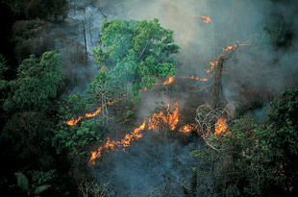
4: Desertification is caused by the complex interactions between physical, biological, social, cultural and economic factors.
Spontaneous or human induced bush and forest fires can severely degrade the environment.
Is Earth, our planet, losing its name? The earth is being degraded. According to estimates, 24 billion tons of fertile soil disappear annually and over the past 20 years, the surface area lost is equal to all of the farmland of the United States of America. Roughly one third of the world’s land surface is threatened by desertification, or put in another way; desertification already affects one quarter of the total land surface of the globe today.
http://www.unesco.org/mab/doc/ekocd/index_learning.html

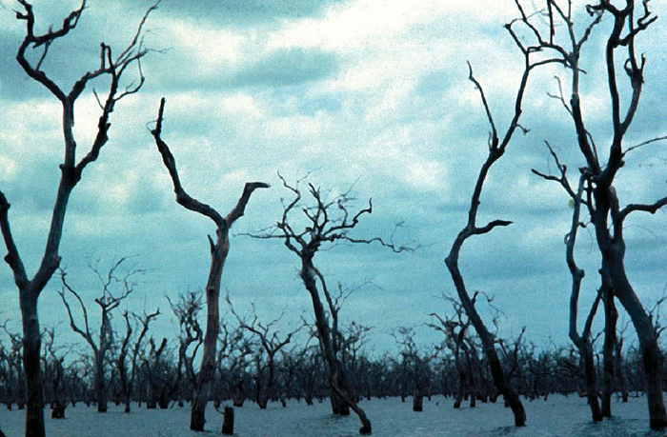
1. Dead trees in India. © Carole Equer, UNESCO
http://www.unesco.org/mab/doc/ekocd/index_learning.html
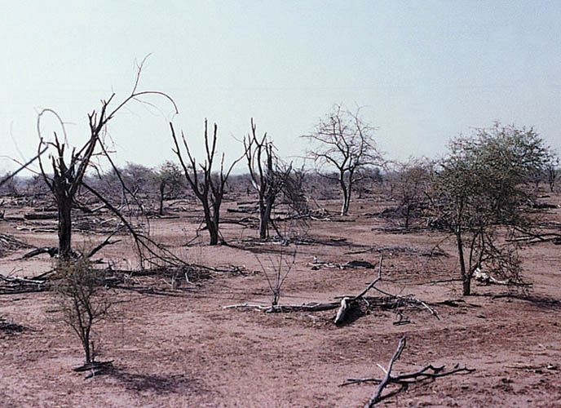
2. Sahelian lands. © UNESCO-MAB
http://www.unesco.org/mab/doc/ekocd/index_learning.html

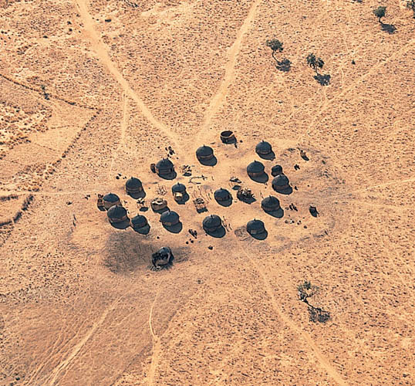
3. Village close to Gao in Mali. The land surrounding populated areas is particularly degraded.
© Yann Arthus-Bertrand, Earth from Above / UNESCO
http://www.unesco.org/mab/doc/ekocd/index_learning.html

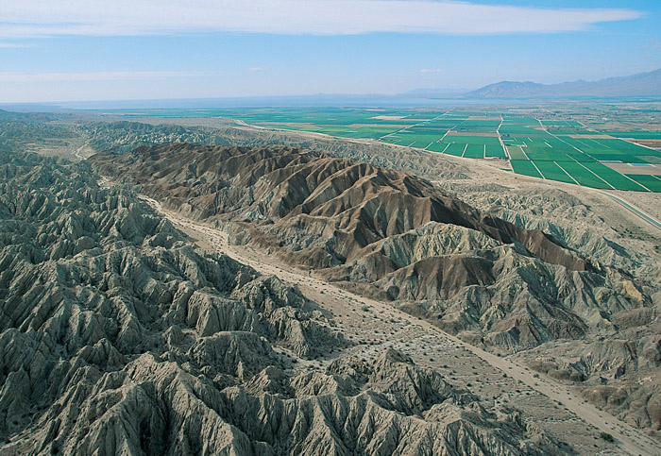
5. California in the USA
© Yann Arthus-Bertrand
http://www.unesco.org/mab/doc/ekocd/index_learning.html

http://www.millenniumassessment.org/documents/document.355.aspx.pdf (p. 17)

According to official estimations, 30% of arableland has been lost due to the degradation of terraces and the lack of maintenance of the irrigation systems. Poor land management has also contributed to a drop in soil fertility. In fact, farmers have forgotten the agricultural practices of their ancestors, which consisted of enriching the soil with mulch and compost, as well as crop rotation and mixed cropping techniques or polyculture. Short-term agricultural production, that takes full advantage of immediate returns, was preferred to the detriment of sustainable development that exhausted resources and damaged the land. Tree logging for firewood is another well-known cause of desertification.

http://www.unesco.org/mab/doc/ekocd/index_case.html

Different categories of drylands
There are four main categories that are distinguished by their temperatures and rain cycles:
Hyper-arid regions:
rainfall is less than 100 mm/year. Drought periods can last longer than a year. Biological productivity is low and the sole viable activity is nomadic pastoralism.
Arid regions:
generally rainfall does not exceed 200 mm/year. These regions are characterized by farming (sedentary or nomadic) and irrigated agriculture.
Semi-arid regions:
rainfall does not exceed 500 mm/year in areas of winter rains or 800 mm/year in areas of summer rains. These regions are characterized by cattle-rearing and sedentary agriculture.
Dry sub-humid regions:
rainfall cycles are highly seasonal. These regions are characterized by rain-fed agriculture. As with semi-arid regions, they are particularly vulnerable to the phenomenon of desertification due to pressure from the rising population.
These regions undergo the same processes of degradation as a result of natural resource over-exploitation and are all characterized by water shortages.
Desertification in the drylands
In all, more than 110 countries have drylands that are potentially at risk. In Africa, a billion hectares or 73% of its drylands are affected by desertification with another 1.4 billion hectares affected in Asia. But it is not just a problem for developing countries, in fact the continent that has the highest proportion of drylands subject to desertification is North America with 74% affected. Five countries of the European Union are also affected while many of the most affected areas are in the former Soviet Union.
http://www.unesco.org/mab/doc/ekocd/index_learning.html

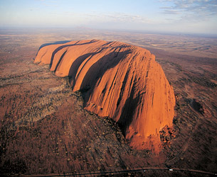
6. Ayers Rock Uluru in Australia: sand dunes.
© Yann Arthus-Bertrand Earth from Above / UNESCO
http://www.unesco.org/mab/doc/ekocd/index_learning.html

Lesson 4 - Gallery Walk Part 2

The Causes of Desertification
The United Nations Convention to Combat Desertification adopted a definition of desertification that attributes the causes of this phenomenon to both climatic variations and human activities. It adds, ‘desertification is caused by complex interactions among physical, biological, political, social, cultural and economic factors’.
Climatic variations: High and sustained temperatures lasting for months with infrequent and irregular rainfall, leads to drought with the effect that vegetation has difficulty growing. This natural phenomenon occurs when rainfall is less than the average recorded levels. As a result, severe hydrological imbalances jeopardize production systems.
Human activities: in countries where major economic resources are dependent on agricultural activities, there are few or no alternative sources of income. Soils become damaged through excessive use when farmers neglect or reduce fallow periods, necessary to sufficiently produce enough food to feed the population. This in turn causes soil to lose organic matter, limiting plant growth and reducing vegetation cover as a consequence. The bare soils are thus more vulnerable to the effects of erosion.
When violent winds and heavy downpours destroy the vegetation, which is then carried away by the sudden gushes of water, the harvests tend to be poorer and the livestock suffer, they eventually become malnourished. As a consequence, the income of the rural communities diminishes. According to the Convention, land degradation brings about a decline or an end to soil productivity, vegetation, arable and grazing lands, as well as forests. In the most extreme cases, hunger and poverty set in and become both the cause and consequence of land degradation.
http://www.unesco.org/mab/doc/ekocd/index_case.html
Over-exploitation of natural resources
Desertification is the accumulated result of ill-adapted land use and the effects of a harsh climate. Four human activities represent the most immediate causes: over-cultivation exhausts the soil, overgrazing removes the vegetation cover that protects it from erosion, deforestation destroys the trees that bind the soil to the land and poorly drained irrigation systems turn croplands salty. Moreover, the lack of education and knowledge, the movement of refugees in the case of war, the unfavourable trade conditions of developing countries and other socio-economic and political factors enhance the effects of desertification. The causes are multiple and interact in a complex manner.
Due to the lack of alternative survival strategies, farmers tend to relentlessly exploit natural resources (food crops, water for drinking and washing, firewood) to the point that they are often over-exploited and cannot regenerate naturally. Soil nutrients and organic matter begin to diminish as intensive agriculture removes quantities of nutrients greater than the soil’s natural regeneration capacities. As a consequence, the soil is unable to recover, as it does during fallow periods, resulting is an ever-increasing spiral of environmental degradation and poverty, the principal causes of desertification.
The principal causes exacerbating land degradation derives from the farmers’ determination to maximize soil productivity, which include:
- crops cultivated in areas at high risk from drought.
- shortening of crop cycles and the reduction of fallow periods.
- insufficient use of fertilizer after harvesting.
- inadequate crop rotation or worse, monoculture.
- intensive labour.
- intense breeding and overgrazing with pressure on vegetation and soil trampling by livestock.
- separation of cattle rearing and agriculture, eliminating a source of natural fertilizer or organic matter (cattle dung) used to regenerate the soil.
- deforestation.
- bush and forest fires.
- in mountainous regions, crops are cultivated along the downward sloping face rather than following the natural contour lines of the mountain.
- deterioration of terraces and other soil and water conservation techniques.
http://www.unesco.org/mab/doc/ekocd/index_case.html

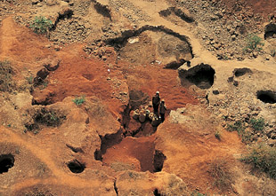
4. Katiola in the Côte d’Ivoire: diamond mines or precious metal open quarries are a cause of desertification. Large surfaces are cleared and turned upside down hundreds of metres into the ground. When the mines are then disaffected the environment is totally destroyed rendering land rehabilitation almost impossible.
© Yann Arthus-Bertrand / Earth from Above / UNESCO
http://www.unesco.org/mab/doc/ekocd/index_case.html
Deforestation and energy
The use of firewood is one of the principal causes of desertification. In tropical arid areas, wood is the principal source of domestic energy for cooking and lighting both in rural and urban populations. In order to limit the need for deforestation, only renewable sources of energy (hydraulic, wind, solar) and gas and petrol should be encouraged as it can replace wood consumption.
Due to the lack of water in the drylands, forest regeneration is very slow, reducing the dynamic growth of vegetation. However, allowing for rest periods from grazing and increasing fallow periods, generally have spectacular regenerating effects on the forest.

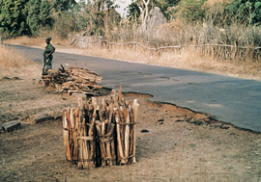
5. Deforestation is a major cause of desertification. In dry tropical zones, wood is the principal source of domestic energy and is also used in construction. In this way, large tracts of forest are destroyed. In the drylands, forest regeneration is very slow because of water scarcity.
© UNESCO-MAB
http://www.unesco.org/mab/doc/ekocd/index_case.html

Population growth
Since the middle of the 20th century many countries have experienced significant population growth (a greater number of children are born while infant mortality decreases slightly, but also people tend to live longer). As a result, the rate of population growth is often high: between 2% and 3% a year, meaning that in certain countries, the population will double within the next 20 to 30 years and with it, a growing population to feed. The ensuing increase in agricultural pressure on land, with the added effect that the soil in the drylands is not given sufficient time to recover, leads to an eventual drop in productivity. Paradoxally, human intervention is required to regenerate degraded lands. People have both the ability to destroy the land and the capacity to restore and rehabilitate their environment.
http://www.unesco.org/mab/doc/ekocd/index_case.html

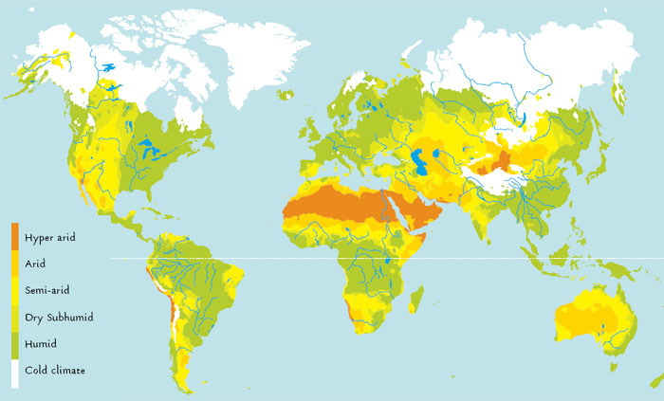
Characteristics of the drylands
The world’s drylands are particularly affected by desertification.
On an environmental basis, these regions are defined by:
- low precipitation that is infrequent, irregular and unpredictable.
- large variations between day and night temperatures.
- soil that is poor in organic matter.
- lack of water for consumption.
- plants and animals adapted to climatic variables (heat resistance, lack of water).
The drylands are comprised of arid, semi-arid and sub-humid areas, the difference being in their degree of aridity. Aridity is the result of the interaction between various climatic factors (rain, temperature, wind) and evapo-transpiration. These elements combine together to determine the growth of plants and the capacities of animals or humans to live fittingly in a harsh natural environment.
http://www.unesco.org/mab/doc/ekocd/index_case.html
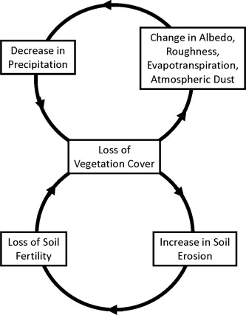

Fig. 4. Examples of desertification feedbacks. Bottom loop: the typical land degradation feedback. The exposure of the soil surface to wind and water erosion causes substantial losses of soil nutrients thereby preventing the re-establishment of vegetation (e.g., and ). This type of feedback invokes the ability of vegetation to stabilize the soil surface as the mechanism that allows the system to persist either in a vegetated or in a bare soil state. Top loop: vegetation-atmosphere feedbacks.
http://www.sciencedirect.com/science/article/pii/S0309170812000231

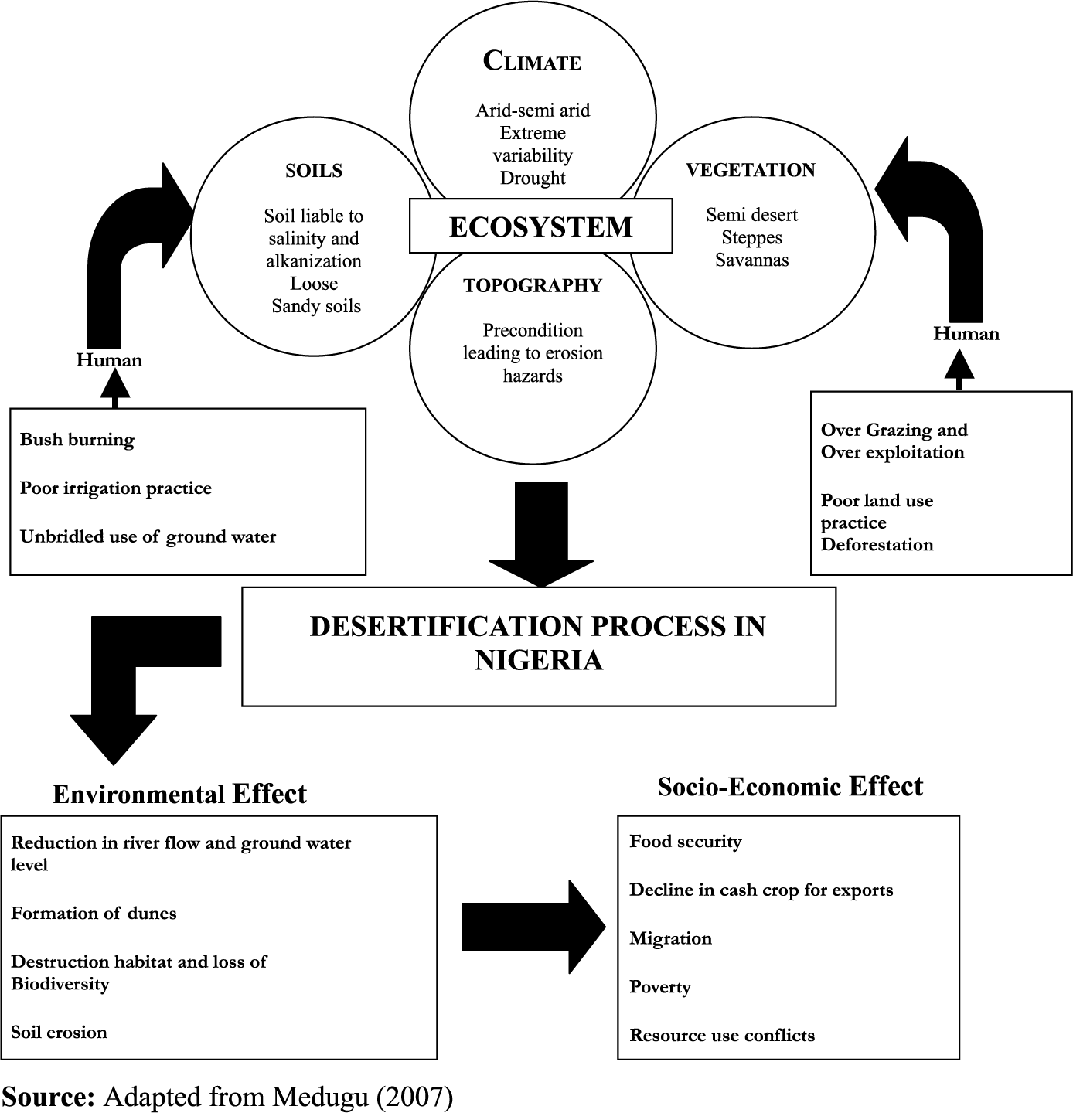
http://geog-leics.blogspot.com/2012/08/from-off-topic-to-case-study.html

Lesson 4 - Gallery Walk Part 3

Water and Desertification

Water quality and the availability of freshwater resources are two of the major environmental issues confronting humanity today. In a way, they can be considered as the single most important issue since water related problems affect the lives of several million people. In the coming years, difficulties relating to water shortages will effectively concern everyone and enormous sums of money will have to be invested in water management. Despite this effort, it will be difficult to improve the situation of 33% of the total world population who do not have access to water, and some 50% of whom lack basic sanitary conditions.
This ‘hydric stress’ already affects 1.7 billion individuals and could affect 5 billion individuals by 2025. Floods and drought kill more people and create more environment damage than any other form of natural catastrophe. The international community is currently combining efforts to improve water management and distribution around the world to ensure a secure future for those populations threatened by the scarcity of freshwater.
Water is a natural resource vital to plant, animal and human life. All life is impossible without it as it regulates the metabolism of every living organism. 70% of the world’s surface is covered with water but only 3% is freshwater of which 79% is in the form of polar ice and 20% exists as inaccessible underground sources. Only 1% is easily available from rivers, lakes and wells.
Under the impact of solar energy, water in lakes and oceans evaporates to the atmosphere in the form of water vapour. When the temperature drops, water vapour condenses and forms clouds, if the temperature drops still further, then the water contained in the clouds falls to earth as rain. Surface water in lakes, rivers and underground reserves originate from this rainfall. Surface or underground water sources finally rejoin the seas and oceans, thereby completing the cycle.
In drylands more than anywhere else, the availability of water is a vital requirement. These areas are characterized by a high rate of evaporation, and surface waters (rivers, lakes) generally tended to disappear relatively quickly. People therefore had to develop different ways to access underground sources (aquifers) to re-route the flow toward areas that require it, particularly the oases. Rainwater penetrates the earth as it flows and replenishes the underground reserves, the presence of trees, bushes and other plants help limit water loss (run-off).

oasis (n.): plural form: oases. A fertile ecosystem situated in a desert zone around a watering hole or in depressions where groundwater reserves are close to the surface
http://www.unesco.org/mab/doc/ekocd/index_case.html

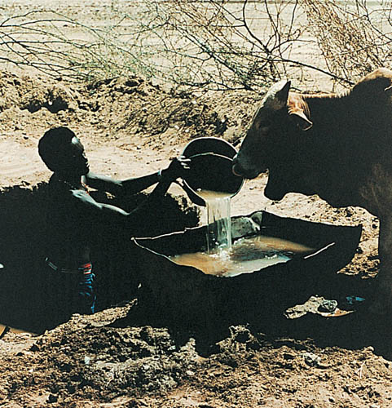
- In the drylands more than anywhere else,
water avalibility determines domestic living conditions as well as the development of pastoralism and agriculture.
© UNESCO-MAB
http://www.unesco.org/mab/doc/ekocd/index_case.html
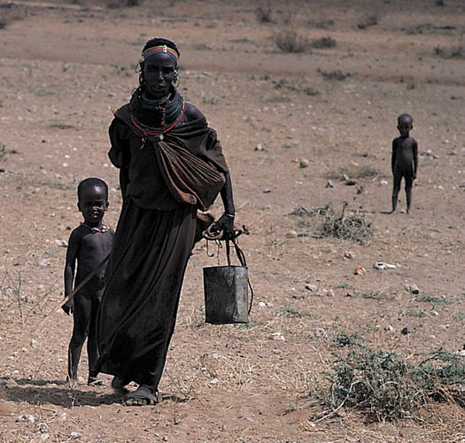
2. Problems linked to water shortages, affecting 1.7 billion people already, could affect 5 billion people in 2025.
© Gisbert Glaser
http://www.unesco.org/mab/doc/ekocd/index_case.html
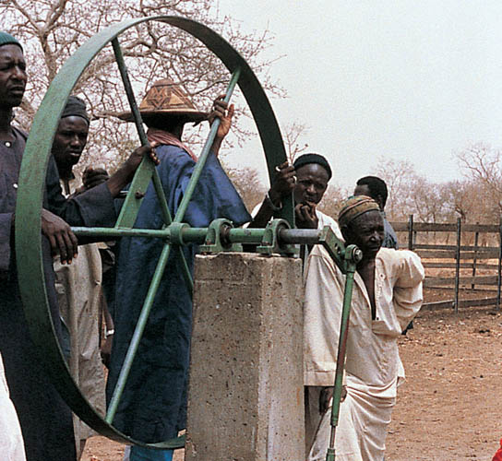
3. Drylands are characterised by extreme evaporation and therefore surface water is extremely rare. People have to resort to different means to access underground reservoirs.
© UNESCO-MAB
http://www.unesco.org/mab/doc/ekocd/index_case.html
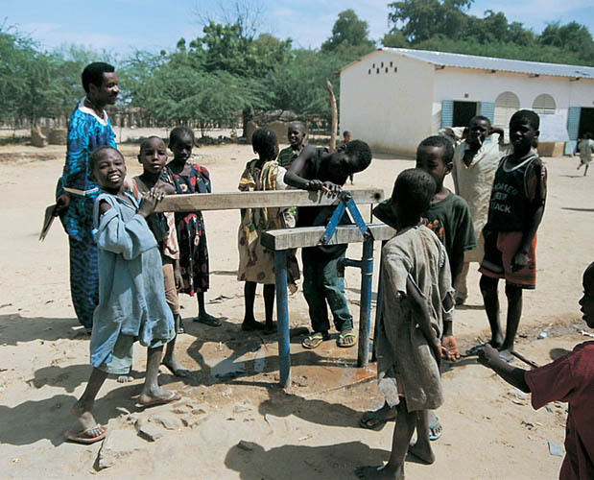
4. Douguia in Chad: a water pump at a local school. In certain regions of the world, freshwater is abundant and is consumed in large quantities, however, in other regions, the slighest water drop is treated as precious.
© Amélie Dupuy
http://www.unesco.org/mab/doc/ekocd/index_case.html

Lesson 4 - Gallery Walk Part 4

Environmental Consequences

Human activities in the drylands, together with climatic factors and drought conditions, influence changes in the natural environment and its productivity. In return, these changes bear consequences on human populations and the quality of life.
http://www.unesco.org/mab/doc/ekocd/index_case.html
Soils erode or disappear
This precious covering, the very flesh of the planet, is painfully slow to form and can be destroyed terrifyingly fast. Just a thin layer of soil can take centuries to develop but, if mistreated, can be blown and washed away in a few seasons. Soil is now rapidly vanishing all over the planet.
Despite the fact that animals and plants are able to adapt to the drylands, desertification has serious consequences on the environment. Depending on the type of agricultural technique employed, different forms of land degradation occur.
The following have been observed:
- loss of nutritive matter (due to agricultural over-exploitation).
- loss of soil surface due to wind and rain erosion, particularly due to the loss of vegetation (See the case study from Spain).
- landslides occur by the action of water, also due to the effects of vegetation loss (See the case study from Kenya).
- increased salinity and soil acidification (due to irrigation malpractice) (See the case study from the Aral Sea).
- soil pollution (due to the excessive use of chemical fertilizer).
- the effects of compression and the encrusting of the soil surface (due to heavy use of agricultural machinery).
http://www.unesco.org/mab/doc/ekocd/index_case.html

Water becomes scarce or is threatened
Land degradation in the drylands can have direct consequences on the water cycle.
If there is low rainfall then drought ensues: groundwater reserves do not refill, water sources become depleted, wells run dry, plants and animals die and humans have to migrate to more hospitable regions.
On the other hand, during periods of high rainfall, the ensuing floods kill people and animals, notably in regions where vegetation cover is reduced or totally destroyed.
The torrential rain flow causes a substantial loss of soil, which is then flushed out by the rains, and when the land becomes dry again, a hard crust forms on the surface that renders it impermeable, reducing water infiltration.
http://www.unesco.org/mab/doc/ekocd/index_case.html
Biodiversity decline
Land degradation due to drought, salinity or over-exploitation has immediate consequences on the capacity of vegetation to maintain or reconstruct itself. Animal species, dependant on this vegetation, have to migrate to other areas to find sufficient resources or they risk disappearing altogether. The importance of this loss derives from the fact that animal and plant species from the drylands are particularly well adapted to this extreme environment. They act as indicators of the environmental condition of these areas and their disappearance is a sign of significant habitat degradation. Moreover, these species remain important resources for the population. Their disappearance increases food insecurity and the impoverishment of the world’s most fragile populations.
http://www.unesco.org/mab/doc/ekocd/index_case.html
Consequences of land degradation
- Erosion: the loose particles and nutritive elements of the soil are flushed out.
- In irrigated lands, where water from underground reserves is often polluted, evaporation leads to a rise in the mineral salts to the surface resulting in high salinity, rendering the soil unsuitable for crops, since they are intolerant of high salt concentrations and may consequently die.
- The vegetation cover is not given enough time to re-establish itself during intensive grazing periods or when grazing activities affect plots that have already been cultivated.
- Due to the acceleration of erosion by rain as a direct result of clearings and deforestation, the forest ecosystem disappears. This has severe consequences on soil fertility as well as on the preservation of animal and plant species.
In fact, roots maintain soil structure and can limit soil erosion since they contribute to water infiltration, which reduces water run-off, encouraging the composition of a rich and productive soil. Also, tree leaves reduce the action of the wind on the soil surface. Dead tree parts that fall to the ground decompose and enrich the soil with organic matter.
http://www.unesco.org/mab/doc/ekocd/index_case.html

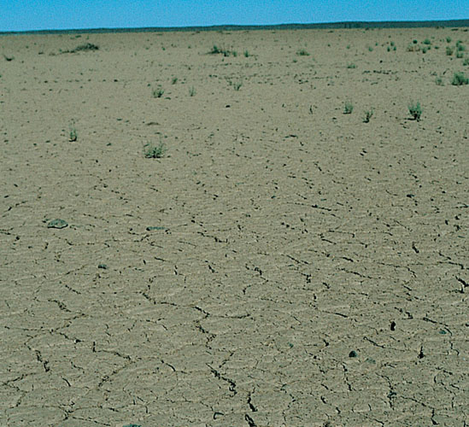
1. When drought periods are sustained, the soil surface hardens and begins to break up. Cracks appear forming deep fissures that damage the soil structure. When rains eventual arrive, the water seeps into the cracks rather than being retained on the surface.
© Jean-Michel Battin
http://www.unesco.org/mab/doc/ekocd/index_case.html
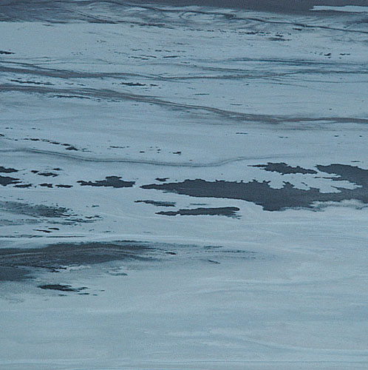
2. Soil salinity has immediate consequences on the ability of vegetation to maintain and regenerate itself.
© Michel Le Berre
http://www.unesco.org/mab/doc/ekocd/index_case.html

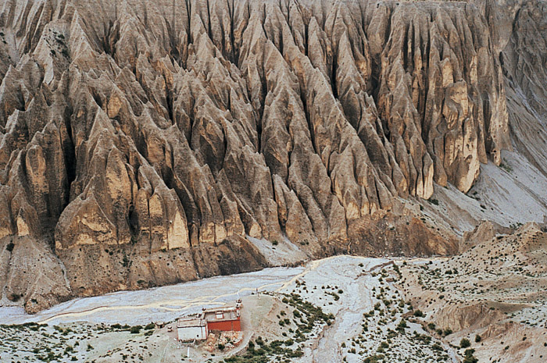
3. Mustang in Nepal: wind erosion. In some cases, the wind causes land erosion, if violent enough, the superficial layers are blown away
© Yazid Tizi
http://www.unesco.org/mab/doc/ekocd/index_case.html
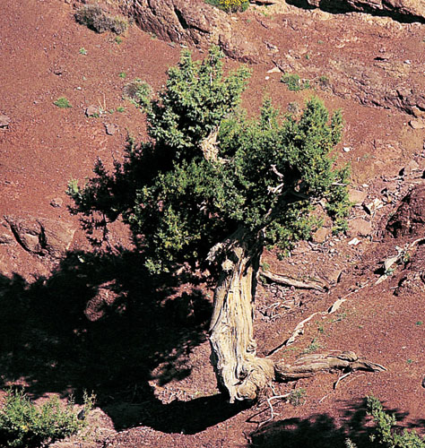
4. Erosion removes part of the soil and often unearths root systems.
© Michel Le Berre
http://www.unesco.org/mab/doc/ekocd/index_case.html
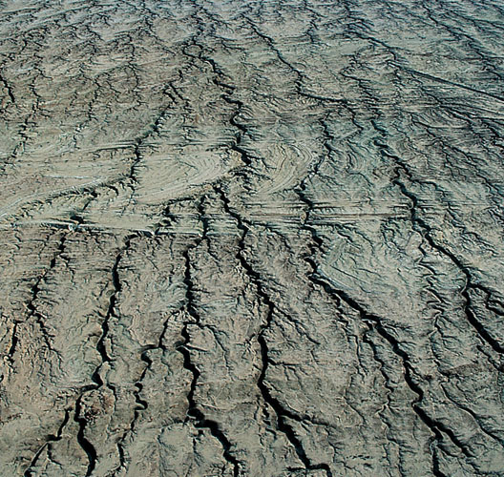
5. 6. Examples of hydraulic erosion. Soils are washed away by the rains, when they dry up, a crust forms that renders the soil impermeable, thereby reducing water infiltration.
© Yann Arthus-Bertrand / Earth from Above / UNESCO
http://www.unesco.org/mab/doc/ekocd/index_case.html

Lesson 4 - Gallery Walk Part 5

Consequences of Desertification on Humans
Desertification leads to poverty with all the social, economical and cutural consequences that this entails. Poverty then drives populations to over-exploit the remaining natural resources triggering a vicious cycle, accelerating land degradation still further. Poverty is thus both a cause and a consequence of desertification. Desertification affects the lifestyles of nearly one billion of the world’s population.
It weakens populations and institutions rendering them more vulnerable to global economic factors. The shortfall in earned tax receipts due to low productivity has consequences on the capacity of governments to reimburse their foreign debt and develop national socio-economic program. The persistence of drought and desertification reduces national food production and furthers the need to turn to foreign products. Moreover, food aid can eventually lead to a reduction in local agricultural production, particularly if it becomes more costly to produce locally than to resort to imported products that are distributed for free by the international community.
http://www.unesco.org/mab/doc/ekocd/index_case.html

Socio-economic development in disequilibrium
Drought and diminishing soil fertility lead to the migration of the rural population. This creates problems in the urban environment as well as in rural areas not yet affected by land degradation, yet witness the migration of new arrivals. The inflated growth of urban centres leads to a reduction in the state budget allowance intended for rural development, which accentuates the rural exodus and raises food insecurity.
Rural populations often lose their possessions during severe drought.
Desertification can drive whole communities to migrate towards cities or regions where survival conditions are initially more promising but ultimately are very difficult: social stability and cultural identity are threatened and the makeshift dwellings, which are insanitary and illegal, are sometimes sources of ethnic or religious conflict.
Economic refugees are increasingly numerous: in Africa estimates place the number at 10 million individuals over the past twenty years.
The population of cities is swelling. Immigrants are often forced to settle in urban slums while rural areas are deserted. Between 1965 and 1988, the proportion of Mauritania’s people living in the capital Nouakchott rose from 9% to 41%, while the proportion of nomads fell from 73% to 7%.
http://www.unesco.org/mab/doc/ekocd/index_case.html
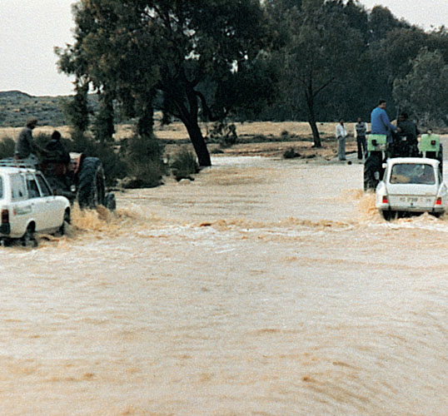
1. In the drylands, rains tend to fall suddenly as violent downpours, leading to flooding along the length of rivers, particularly where embankments are degraded.
© UNESCO-MAB
http://www.unesco.org/mab/doc/ekocd/index_case.html
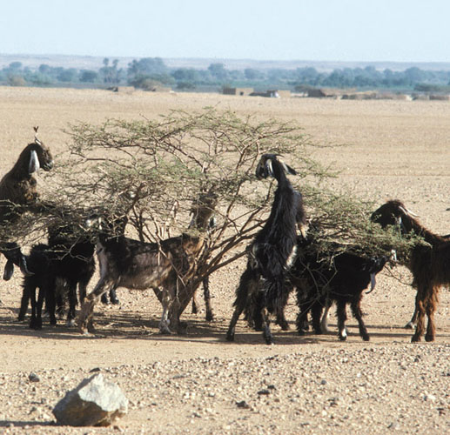
2. When drought conditions and low soil fertility become overwhelming, people and animals do not have enough resources to feed themselves and they are obliged to move to other areas.
© FAO/14204/R. Faidutti
http://www.unesco.org/mab/doc/ekocd/index_case.html

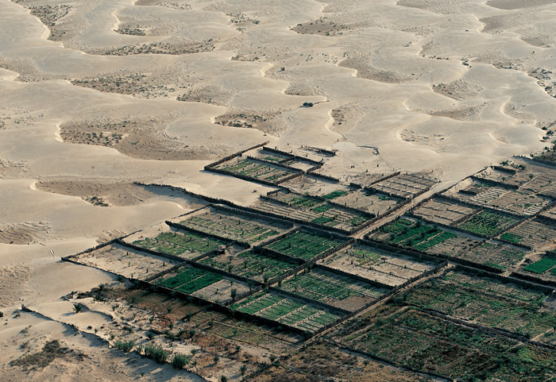
3. The encroachment of the desert around the oases necessitates permanent crop protection.
© Yann Arthus-Bertrand / Earth from Above / UNESCO
http://www.unesco.org/mab/doc/ekocd/index_case.html
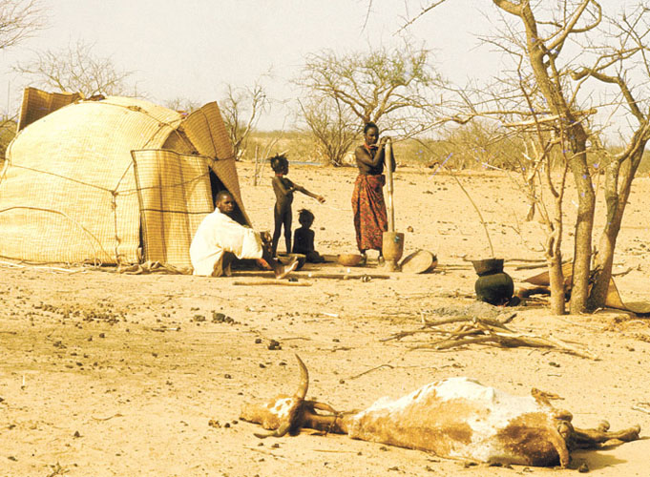
4. Due to general drought conditions in the Sahel, the nomads in Mali encounter in neighbouring Burkina Faso, the same degraded lands and lack of food.
© FAO/6715/F. Botts
http://www.unesco.org/mab/doc/ekocd/index_case.html

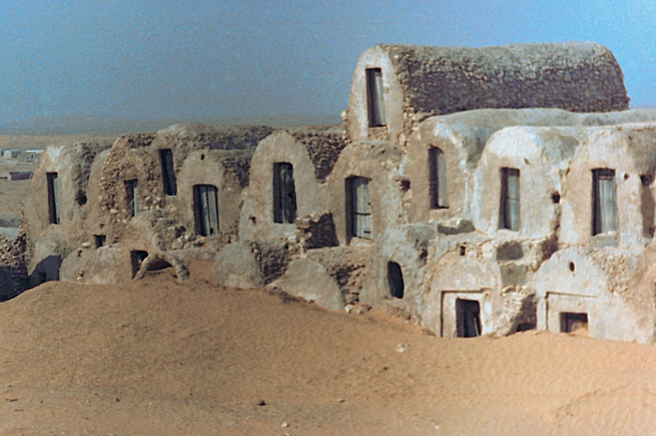
5. Mobile, shifting sands gradually engulf dwellings thus leading to the abandonment of certain villages.
© UNESCO-MAB
http://www.unesco.org/mab/doc/ekocd/index_case.html

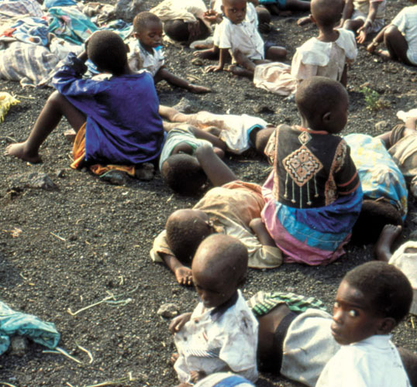
6. During armed conflict, refugees are often obliged to settle temporarily in camps where they try to survive in often appalling conditions. Poor hygiene and relentless exploitation of resources contribute to the intensification of environmental degradation.
© F. Loock, UNESCO
http://www.unesco.org/mab/doc/ekocd/index_case.html

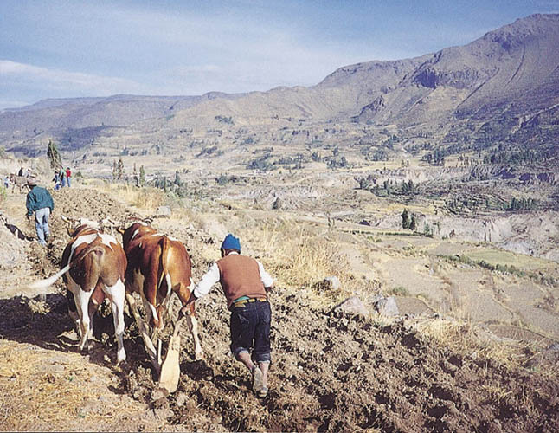
2. Agriculture on mountainous regions is rendered difficult by its steep slopes and the risks of erosion. Here the men
plough the flat fields thanks to the construction of terraces.
© UNEPs Success Stories photo archive
The mountainous zones are characterized by dramatic water shortages, steep slopes and serious climatic limitations on agriculture (frosts, low atmospheric humidity). Average annual rainfall is 350 mm, of which 60% is concentrated between January and March with only one harvest a year. Small land properties are common and on average, each family possesses 1.2 hectares, split up into several smaller plots distributed among different ecological zones. In general, farmers cultivate between eight and sixteen different crop varieties, maize, beans, potatoes, barley and quinoa being the more common among them. The traditional techniques adopted to overcome environmental difficulties consisted essentially of terraces, irrigation networks and the beneficial effects of the microclimate present at varying altitudinal levels.
http://www.unesco.org/mab/doc/ekocd/index_case.html

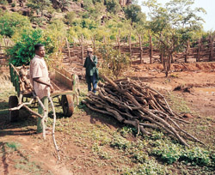
During the past twenty years, Niger has experienced rapid population growth with greatly increasing pressure on energy sources. Wood is the primary source of domestic energy and collection of this resource has reached alarming proportions. This situation adds to the current constraints placed on food reserves and adds to other factors such as drought, poor development of agriculture and overgrazing.
The consequences of this are clear: the forests are damaged and the process of desertification has accelerated. In an attempt to contain the phenomenon and promote sustainable development through the controlled exploitation of wood resources, the Government of Niger has introduced a system of ‘domestic energy strategy’ (DES) insisting on the need for participation among rural communities to sell wood within a controlled system of rural markets.
Studies undertaken in 1990 show that the town of Niamey consumes as much as 133,000 tons of wood a year. By 1994, the growing population led to an increase in demand, which has now reached 150,000 tons.
http://www.unesco.org/mab/doc/ekocd/index_case.html

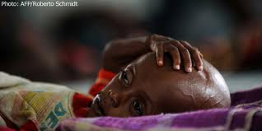

Gambia is one of the poorest and most densely populated countries in Africa. Situated in the Sahelian region of West Africa, it is characterized by a Sudano-sahelian climate. Since the late 1960s, Gambia has been subject to severe devastating drought, the worst being the drought of 1968-74.
Gambia has a predominantly agricultural based economy with an estimated 72% of the population directly engaged in agricultural activities. The agricultural system of extensive cropping is widespread and includes massive clearings anddeforestation since productivity depends on the agricultural land available. The deforestation rate in Gambia is 6% per year. In addition to deforestation, the country suffers serious land degradation caused by cattle. Ill-adapted agricultural practices such as continuous cropping without the use of natural fertilizers and the application of bush fires have left their mark on the environment with disastrous consequences
http://www.unesco.org/mab/doc/ekocd/index_case.html

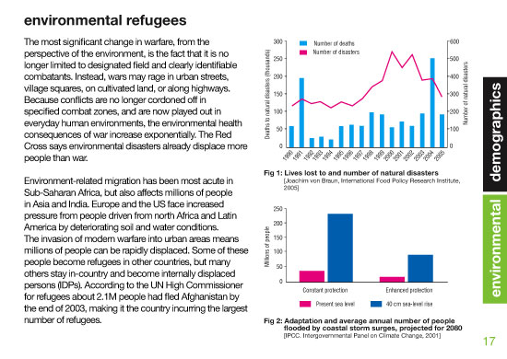
http://www.driversofchange.com/demographics/environmental_refugees/

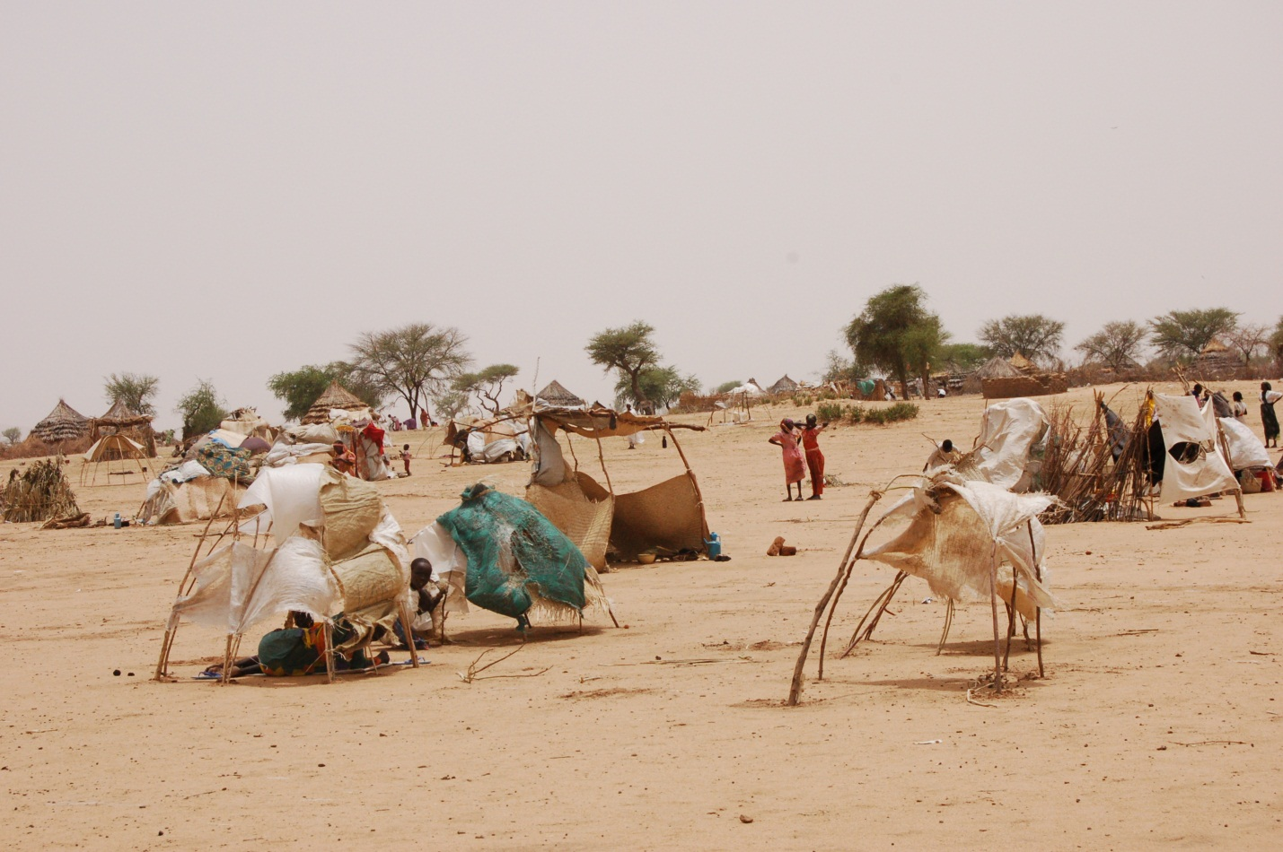
Darfur Refugess – Desertification. An IDPs Camp in Darfur
06 Jun 2006, Owner: UNEP
http://postconflict.unep.ch/sudanreport/sudan_website/index_photos_2.php?key=desertification

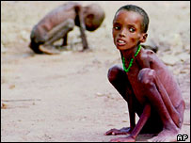
One of the biggest sources of refugees is land degradation and desertification
Janos Bogardi
http://news.bbc.co.uk/2/hi/science/nature/4326666.stm

Present Day Drylands and their Categories
UNEP. (2005) Ecosystems and Human Well Being: Desertification Synthesis. P. 23. http://www.unep.org/maweb/documents/document.355.aspx.pdf

Lesson 4 - “Water is Life” Graphic Organizer for Conceptual Model

Name:
Date:

TITLE OF YOUR MODEL:

DETAIL 1 | DETAIL 2 | DETAIL 3
SCIENTIFIC VOCABULARY: | SCIENTIFIC VOCABULARY: | SCIENTIFIC VOCABULARY:
EXPLAIN HOW THE DETAIL CLARIFIES THE MODEL. | EXPLAIN HOW THE DETAIL CLARIFIES THE MODEL. | EXPLAIN HOW THE DETAIL CLARIFIES THE MODEL.
EXPLANATION OF YOUR MODEL:

CITATION FOR YOUR MODEL

Lesson 4 - “Water is Life” Text Dependent Questions

Name:
Date:

Paragraphs 6-9
- In paragraphs 6, 7, and 8, Kingsolver describes one example of people living in the Piura Desert in order to show what it is like to live in an area of extreme drought. Underline examples in the text of the challenges they face.
- Explain what Kingsolver means when she writes, “I climbed the sand mound to hide my unprofessional tears. Why do you think Kingsolver had tears in her eyes? What experiences has she shared in earlier parts of the text that might make her feel sad for the people living in the desert?
- Kingsolver came to the desert to learn about “an innovative reforestation project.” What was the purpose of the project? Why do you think reforestation in a desert is innovative?

Lesson 5 - Outline of Universe Models: Aristotle through Kepler

How Models Change with New Technology and New Information
Adapted from Our Expanding Universe Slide Show by
NASA - Harvard - Smithsonian Institute for Astrophysics
http://www.cfa.harvard.edu/seuforum/einstein/resources_ed.htm

Throughout time, humans have tried to create a model of the cosmos.

In Kingsolver’s article she mentions that it took a long time for scientists and society to change their minds about the Earth being the center of the universe. This is a classic example of the integral relationship between technology and our understanding of how the world works.

Cosmology through the ages...

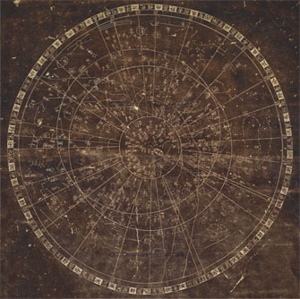

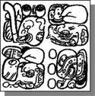

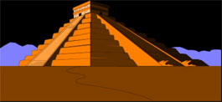



Long before telescopes and modern astronomy, cultures around the globe were keen observers of the sky, and created maps an models to understand our place in the universe. Most of them suggested that the Earth was at the center!

Top Right: Stela glyphs that refer to “Cosmic Monster” that split to become earth and sky (Milky Way);
Top Left: 11th Century Chinese map of stars in the sky, believed to indicate supernova of 1054
Second Row: Mayan temple aligned with Sun;
Bottom: Representation of Cosmos (Earth at the center -- starry cosmos all around) painted by Hildegard of Bingen, 11th Century nun

Earth-centered Cosmology Claudius Ptolemy, 100-170 AD
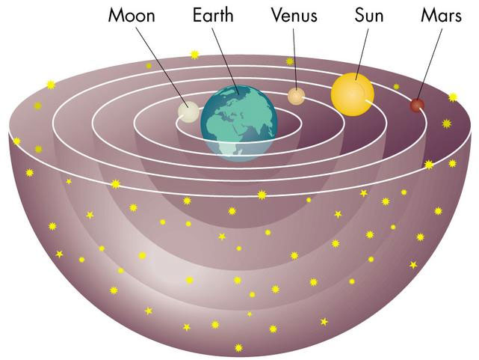

The first “scientific "model, one that was created by the documentation of the movements of the stars and moon, was created by Aristotle.

In this model the planets were considered to move within crystalline spheres.
All spheres rotated once a day with the planetary spheres slipping slightly with respect to the outermost (starry) sphere, which accounts for their motions against the starry background. Comets were atmospheric effects caused by the friction of the innermost sphere against the upper atmosphere.

Testing the Earth-centered Model

Prediction: Future planetary positions
Observation: Retrograde motion of planets
Refine: Epicycles

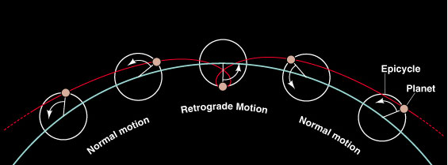

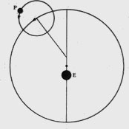

After Aristotle, Ptolemy’s observations suggested that there were other planets and that the Earth was overtaking the other planet on its inside orbit, it was unexplainable on the geocentric model. This model lasted 1500 years.

Testing the Earth-centered Model

Prediction: Phases of Venus
Observation: Full set of phases

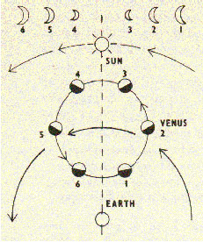

Crisis!
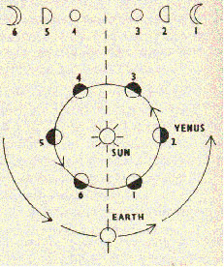

Galileo’s observations of the phases of Venus took place in 1615/16.
Note that the observation proves the Ptolemaic model wrong, but does not prove the Copernican model right.

The Danish astronomer Tycho Brahe (1546-1601) developed a geocentric model that would also allow Venus to show a full set of phases.

Sun-centered Cosmology: Nicolaus Copernicus 1473 - 1543

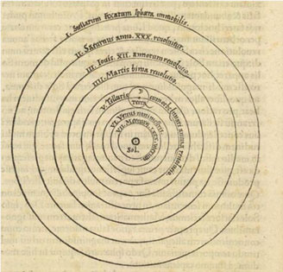

Sometimes a new model is needed to explain observations.

The Copernican revolution was more of a gradual persuasion that an epiphany. At the time the model was presented (Copernicus was on his death bed as it was printing) there was no observational evidence favoring it over the geostatic cosmology.

Testing the Sun-centered model

Prediction: Future planetary positions
Observation: No better than Ptolemy
Refine: Elliptical orbits (Johannes Kepler 1571-1630)

In 1602, Kepler discovered the elliptical nature of planetary orbits in 1602.

The elliptical orbits of the planets are so close to circles that you could not distinguish them by eye. They were elliptical enough however, to make planetary predictions by the Copernican model just as inaccurate as by Ptolemy.

Lesson 5 - “Water is Life” Text Dependent Questions

Name:
Date:

Paragraph 10
- When Kingsolver uses the phrase “that round slip of sky with stars has comforted me,” what do you think she is talking about?

- Kingsolver uses the phrase “look up from the bottom of a well and see the stars, even in daylight” to describe how people once viewed the Earth. She also mentions Aristotle as a clue to help us understand how people understood the relationship between the stars and the Earth. Do these clues help you? If not, what questions do they make you ask yourself?
- Aristotle, a Greek philosopher known as the “father of science,” challenged humans to question common assumptions about nature by asking questions and making observations to find the truth rather than the “folklore”. Because this paragraph is about how people once viewed the Earth, what “discovery” do you think astronomers made that dashed humans’ illusion about being the center of the universe? Why is this important to Kingsolver’s thesis?

Lesson 5 - Criteria for Strong Scientific Models and Explanations

Name:
Date:

1. The model explains relationships:
- The model accurately explains or describes the interactions the different Earth’s systems

2. The model and explanation is scientifically sound:
- testable;
- adaptable (responsive to new information);
- states limitations;
- research based; (citation needed)
- uses appropriate vocabulary

3. The model and explanation is easy to understand
- The focus of the model can easily be identified
- The information portrayed makes sense
- Labels are readable
- More complex labels are explained

4. The model and explanation is simple and elegant
- The model is understandable
- The model is elegant

Lesson 5 - “Water is Life” Graphic Organizer for Conceptual Model

Name:
Date:

TITLE OF YOUR MODEL:

DETAIL 1 | DETAIL 2 | DETAIL 3
SCIENTIFIC VOCABULARY: | SCIENTIFIC VOCABULARY: | SCIENTIFIC VOCABULARY:
EXPLAIN HOW THE DETAIL CLARIFIES THE MODEL. | EXPLAIN HOW THE DETAIL CLARIFIES THE MODEL. | EXPLAIN HOW THE DETAIL CLARIFIES THE MODEL.
EXPLANATION OF YOUR MODEL:

CITATION FOR YOUR MODEL

Lesson 6 - “Water is Life” Text Dependent Questions

Name:
Date:

Paragraphs 4-5
- In paragraph 4, Kingsolver writes, “The past decade has brought us more extreme storms than ever before.” What evidence does she cite to support this claim?
- In paragraph 5, Kingsolver uses the phrase, “water will flow from snowcapped mountains, rain and sun will arrive in their proper seasons” to describe how we understand water. Does Kingsolver still believe this? What phrases or questions does she use to support her beliefs?
- In paragraph 2, in the final sentence, Kingsolver uses the phrase “pounding circulatory system of the world.” How does this relate to what you now know about the properties and movement of water in the hydrosphere?

Lesson 6 - Hydrological Cycle – Conceptual Model #1
https://www2.ucar.edu/atmosnews/people/aiguo-dai

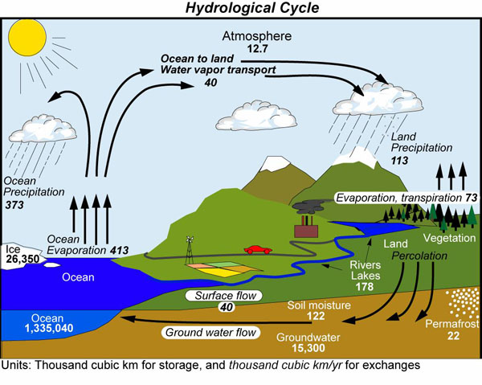

This illustration of the hydrological cycle shows water changing phase, from liquid to solid to gas and back to liquid, as it moves through the Earth system. The estimated global volume of water stored in each part of the system or exchanged with another part during a year is given in cubic kilometers (1 cubic km = 0.244 cubic miles). Aiguo and colleagues estimated these long-term means, or averages, based on available data, which comes mostly from the latter half of the 20th century. Aiguo is examining the impact of climate change, including global warming, on water storage and exchange. [ENLARGE] (Illustration from Trenberth et al., 2007, Estimates of the global water budget and its annual cycle using observational and model data, Journal of Hydrometeorology.)

Lesson 6 - Hydrological Cycle – Conceptual Model #2
http://www.britannica.com/EBchecked/topic/278858/hydrologic-cycle

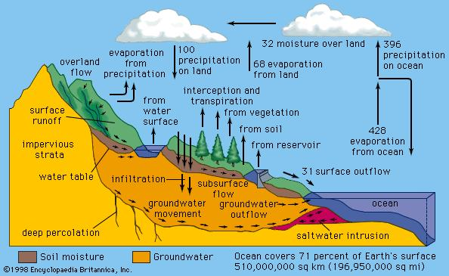

Figure 4: The detailed hydrological processes involved in the transfer of water in the cycle. The numbers on the arrows show the relative water fluxes.

Lesson 6 - Hydrological Cycle – Conceptual Model #3
http://www.epa.gov/climatechange/impacts-adaptation/water.html
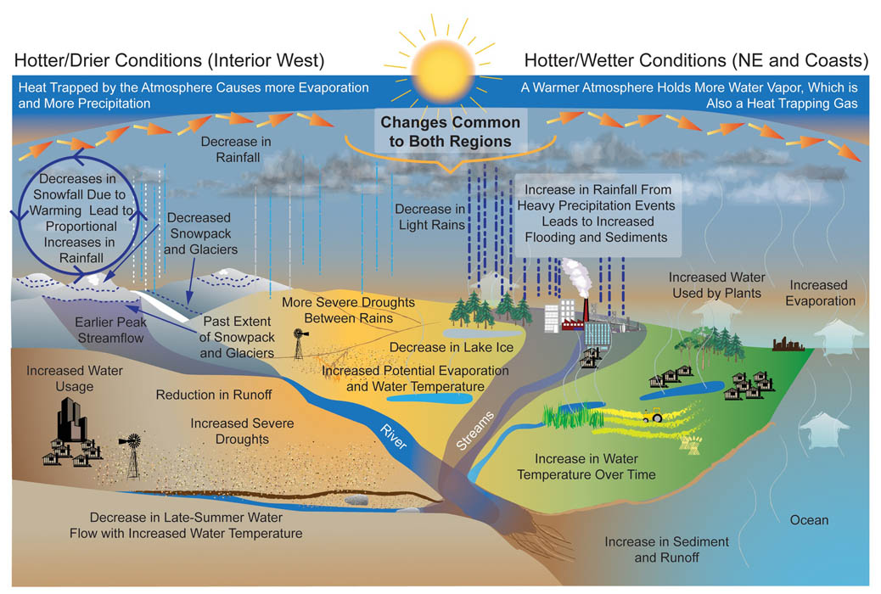
The water cycle (shown above) is a delicate balance of precipitation, evaporation, and all of the steps in between. Warmer temperatures increase the rate of evaporation of water into the atmosphere, in effect increasing the atmosphere's capacity to "hold" water. ^{[1]} Increased evaporation may dry out some areas and fall as excess precipitation on other areas.

Changes in the amount of rain falling during storms provide evidence that the water cycle is already changing. Over the past 50 years, the amount of rain falling during the most intense 1% of storms increased by almost 20%. ^{[1]} Warming winter temperatures cause more precipitation to fall as rain rather than snow. Furthermore, rising temperatures cause snow to begin melting earlier in the year.

This alters the timing of streamflow in rivers that have their sources in mountainous areas. ^{[1]}
As temperatures rise, people and animals need more water to maintain their health and thrive. Many important economic activities, like producing energy at power plants, raising livestock, and growing food crops, also require water. The amount of water available for these activities may be reduced as Earth warms, and if competition for water resources increases. ^{[1]}

1. USGCRP (2009). Global Climate Change Impacts in the United States . Karl, T.R. J.M. Melillo, and T.C. Peterson (eds.). United States Global Change Research Program. Cambridge University Press, New York, NY, USA.

Lesson 6 - Hydrological Cycle – Conceptual Model #4
http://www.bbc.co.uk/scotland/education/int/geog/rivers/hydrological.shtml


The global hydrological cycle explains the distribution of water as it moves as either a liquid, solid or vapour between the ocean, the atmosphere and the land. The total amount of water in the cycle is always the same; no water is added or lost. This is a good example of a closed system. The diagram shows the various stages of the hydrological cycle. Drag and drop the labels onto the correct stage in the cycle.
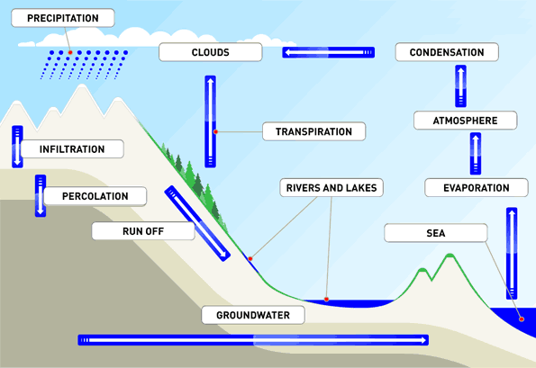
The hydrological cycle is powered by solar energy. The sun heats water from the ocean, lakes, rivers and the Earth’s surface. This water then evaporates into the atmosphere. Additional water is drawn from the soil by plants, and is then evaporated into the atmosphere from leaves and stems. This process is calledtranspiration.
As the air rises and the temperature drops, the moisture-laden air condenses, forming clouds and eventually resulting in precipitation in the form of rain or snow. Surface run-off makes its way back to the ocean viarivers. Other water seeps into the soil. This process is called infiltration. If the rock below the soil is permeable, then the water percolates the rock and is stored as groundwater.

Lesson 7 - Chalk Talk Recording Form

Name:
Date:

Listen for the following phrases; capture your thoughts.

 | Notice | Wonder
We live at a time in history where over a billion people do not have access to safe drinking water and over 3 billion do not have access to sanitation.
Water is a global issue but it also is a very local issue…
Water that runs in the Ganges could also end up in the Hudson, or fall over the plains of Africa, or could make a cup of tea for the Queen of England.
We are using and abusing our water resources and unless we take action at an individual level, I do not see how we can overcome the issues we will face in the next 50 years.
70% of the water extracted from rivers, lakes, and aquifers goes to irrigated agriculture. To some extent we are using some of tomorrow’s water to meet today’s food demands.
The great American lawn is a great example of the myriad of ways people in the US take water for granted.

Lesson 7 - “Water is Life” Text Dependent Questions

Name:
Date:

Paragraphs 12-14
- In these paragraphs, Kingsolver summarizes her thesis statement. Earlier in the text, she used the phrase “water is life.” In this section she uses the phrase, “water is the ultimate commons.” How are these two phrases similar? What makes water the “ultimate commons”?
- In the paragraph 12, Kingsolver writes, “Surely it was no sin, once upon a time, to shoot and make pies of passenger pigeons,” to forgive people for not understanding that once the passenger pigeon was gone, there would be no more. Because of the loss of the passenger pigeon, we now have laws to protect animals. Why does Kingsolver use this example in an article about water?
- Kingsolver uses Garret Holland’s concept of “the Tragedy of the Commons,” to support her thesis that we must take care of water…for the good of everyone. What are other environmental issues that are also related to “the Tragedy of the Commons?” What common factors can you identify between these other environmental issues and the concern over water and climate change expressed by Kingsolver?
- In the paragraph 14, Kingsolver used the image “a glass of water has caught the afternoon light, and I am still looking for wonders.” How did she refer to wonders at the beginning of this article? What level of wonder is she looking for at the end of the article?
- What does the phrase “good news” refer to in the fifth sentence of paragraph 14? What connections can you make to “good news” in this article? Where else in the text does Kingsolver talk about conservation of natural resources?
- To protect the commons, Kingsolver recommends that we have “tools of a new century.” What tools is she referring to?

Lesson 8 - Human Influences on the Water Cycle

http://www.sswm.info/category/concept/water-cycle

Name:

Date:
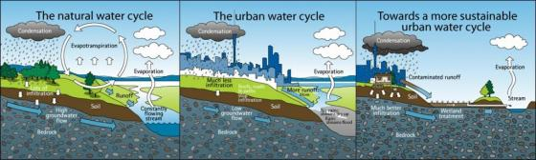

Humans significantly influence the global water cycle, both quantitatively and qualitatively. Concerning quantity, humans withdraw 8% of the total annual renewable freshwater, and appropriate 26% of annual evapotranspiration and 54% of accessible runoff. Humankind’s control of runoff is now global and we are significant players in the hydrological cycle. Per capita use is increasing (with better lifestyles) and population is growing. Thus the percentage of appropriated water is increasing. Together with spatial and temporal variations in available water, the consequence is that water for all our uses is becoming scarce and leading to a water crisis (WWAP 2003). Local water cycles are also influenced by the way we plan our cities: When land is paved, water cannot soak into the soil. It runs off these hard surfaces very rapidly, so pipes are needed to rapidly carry the resulting large volumes of stormwater to the nearest stream or beach. The result is that streams carry less water or dry up when it is not raining and flood when it does. Pollutants on roads and yards are also swept into waterways (see also sustainable sanitation).

Appendix C: Protocols

- Admit and Exit Tickets
- Chalk Talk
- Checking for Understanding
- Close Reading
- Jigsaw
- Science Notebook Entry Types
- Science Notebook Organization
- Silent Gallery Walk
- Questioning Strategies to Engage All Learners
- Word Wall



Admit and Exit Tickets Protocol

Purpose: At the end of class, students write on note cards or slips of paper an important idea they learned, a question they have, a prediction about what will come next, or a thought about the lesson for the day. Alternatively, have students turn-in such a response at the start of the next day–either based on the learning from the day before or the previous night’s homework. These quick writes can be used to assess students’ knowledge or to make decisions about next teaching steps or points that need clarifying. This reflection helps students to focus as they enter the classroom or solidifies learning before they leave.

Procedure:
For 2–3 minutes at the end of class (or the start of the next one) have students jot responses to the reading or lesson on 3 x 5 note cards.

Keep the response options simple–“One thing you learned and one question you have.” If you have taught particular thinking strategies–connecting, summarizing, inferring–ask students to use them.

A variation is known as 3-2-1: Have students write three of something, two of something, then one of something. For example, students might explain three things they learned, two areas in which they are confused, and one thing about which they’d like to know more or one way the topic can be applied. The criteria for listing items are up to the needs of the teacher and the lesson, but it’s important to make the category for three items easier than the category for listing one item.

Don’t let the cards become a grading burden. Glance over them for a quick assessment and to help you with planning for next learning needs. These are simply quick writes, not final drafts.

After studying the “deck” you might pick-out a few typical/unique/thought-provoking cards to spark discussion.

Cards could be typed up (maybe nameless) to share with the whole group to help with summarizing, synthesizing, or looking for important ideas. It is a good idea to let students know ahead of time as they may put more effort into the write-up. When typing, go ahead and edit for spelling and grammar.

Chalk Talk Protocol

A Method for Having a Silent Discussion about an Important Issue

Overview: A chalk talk is a simple procedure to promote discussion and awareness of issues and perspectives–silently. A chalk talk is also an excellent way to promote awareness of patterns and problems, and to insure that all voices are heard.

Formulate an important, open-ended question that will provoke comments and responses.

Provide plenty of chart paper and colored pencils and arrange a good space for participants to write and respond. Write the question or topic in the middle of the paper in bold marker.

Explain the chalk talk protocol and answer any participant questions.

Set-up norms for the chalk talk: This technique only works if everyone is writing and responding throughout the designated time period. Make it clear that everyone is responsible for writing, reading other people’s comments, and responding; there should be no talking; and no one should sit down until the time period is over. Opinions must be freely expressed and honored, and no personal attacks are allowed.

Allow 10-20 minutes for the chalk talk. As facilitator, it’s helpful to walk around and read, and gently point participants to interesting comments. All writing and responding is done in silence.

Search for patterns. In pairs, participants should read through all the postings and search for patterns and themes (or “notice and wonder”). This part takes about 5 minutes.

Whole-group share: Pairs should report out patterns and themes, round-robin style, until all perceptions are shared.

Process debrief: What was the experience like of “talking” silently?

C h e c k i n g f o r U n d e r s t a n d i n g : K e y A s s e s s m e n t f o r L e a r n i n g T e c h n i q u e s

When we check all students' levels of understanding throughout each lesson, it sets the tone that everyone's thinking is important and necessary, and we forward the learning and engagement of all. Some techniques are too time-consuming to use as quick pulse checks, but using these key techniques together in all lessons allows us to track learning and adapt instruction appropriately on the spot.

In all lessons, teachers should:

Ground the lesson in the learning target. This means they:
- Post the target in a visible, consistent location
- Discuss the target at the beginning of class with students, having students put the target into their own words, explain its meaning, and explain what meeting the target might look like
- Reference the target throughout the lesson
- Return explicitly to the target during the debrief, checking for student progress

Use Cold Call. This means they:
- Name the question before identifying students to answer it
- Call on students regardless of whether they have hands raised, using a variety of techniques such as random calls, tracking charts to ensure all students contribute, name sticks or name cards
- Scaffold the questions from simple to increasingly complex, probing for deeper explanations
- Connect thinking threads by returning to previous comments and connecting them to current ones. In this way, listening to peers is valued, and even after a student's been called on, s/he is part of the continued conversation and class thinking

Use No Opt Out. This means they:
- Require all students to correctly answer questions posed to them
- Always follow incorrect or partial answers from students by giving the correct answer themselves, cold calling other students, taking a correct answer from students with hands raised, cold calling other students until the right answer is given, and then returning to any student who gave an incorrect or partial answer for complete and correct responses

Use guided practice before releasing students to independent application. This means they:
- Ask students to quickly try the task at hand in pairs or in a low-stakes environment
- Strategically circulate, monitoring students' readiness for the task and noting students who may need re-teaching or would benefit from an extension or more challenging independent application
- Use an appropriate quick-check strategy (see below in Tools/Protocols section) to determine differentiation or effective support during independent application time

End with an effective debrief. This means they:
- Return explicitly to the learning targets (both academic and character/habits of work)
- Elicit student reflection towards the learning target(s), probing for students to provide evidence for their own and/or class progress
- Celebrate or have students celebrate individual, small group or whole class successes
- Identify or have students identify goals for improvement around the target(s)

Quick-Check Tools and Protocols

The following tools and protocols promote engagement by checking for all students' understanding and by reflecting on and emphasizing effective work habits.

Whip-Around: When a one- or two-word answer can show understanding, self- or group assessment, or readiness for a task, teachers ask students to respond to a standard prompt one at a time, in rapid succession around the room.

Whiteboards: Students have small white boards at their desks or tables and write their ideas/thinking/ answers down and hold up their boards for teacher and/or peer scanning.

Hot Seat: The teacher places key reflection or probing questions on random seats throughout the room. When prompted, students check their seats and answer the questions. Students who do not have a hot seat question are asked to agree or disagree with the response and explain their thinking.

Fist-to-Five or Thumb-Ometer: To show degree of agreement, readiness for tasks, or comfort with a learning target/concept, students can quickly show their thinking by putting their thumbs up, to the side or down; or by holding up (or placing a hand near the opposite shoulder) a fist for 0/Disagree or 1-5 fingers for higher levels of confidence or agreement.

Glass, Bugs, Mud: After students try a task or review a learning target or assignment, they identify their understanding or readiness for application using the windshield metaphor for clear vision. Glass: totally clear; bugs: a little fuzzy; mud: I can barely see.

Red Light, Green Light: Students have red, yellow and green objects accessible (e.g. popsicle sticks, poker chips, cards), and when prompted to reflect on a learning target or readiness for a task, they place the color on their desk that describes their comfort level or readiness (red: stuck or not ready; yellow: need support soon; green: ready to start). Teachers target their support for the reds first, then move to yellows and greens. Students change their colors as needed to describe their status.

Table Tags: Place paper signs/table tents in three areas with colors, symbols or descriptors that indicate possible student levels of understanding or readiness for a task or target. Students sit in the area that best describes them, moving to a new area when relevant.

Sticky Bars: Create a chart that describes levels of understanding, progress or mastery. Have students write their names or use an identifying symbol on a sticky note and place their notes on the appropriate place on the chart.

Learning Line-ups: Identify one end of the room with a descriptor such as "Novice" or "Beginning" and the other end as "Expert" or "Exemplary". Students place themselves on this continuum based on where they are with a task or learning target. Invite them to explain their thinking to the whole class or the people near them.

Human Bar Graph: Identify a range of levels of understanding or mastery (e.g. beginning/developing/ accomplished or Confused/I'm okay /I am rocking!) as labels for 3-4 adjacent lines. Students then form form a human bar graph by standing in the line that best represents their current level of understanding.

Admit and Exit Slips: Any relevant questions, prompts, or graphic displays of student thinking can be captured on a small sheet of paper and scanned by the teacher or other students to determine a student's readiness for the next step or assess learning from a lesson. Teachers may use admit slips as a "ticket to enter" a discussion, protocol or activity. These may also be used as "tickets to leave."

Presentation Quizzes: Whenever peers present, other students may think they are not responsible for the information. Pair student presentations and sharing with short quizzes at the end of class.

Catch and Release/7:2: When students are working on their own, they often need clarification or pointers so that they do not struggle for too long of a period or lose focus. A useful ratio of work time to checks for understanding or clarifying information is 7 minutes of work time (release), followed by 2 minutes of teacher-directed clarifications or use of one of the quick-check strategies (catch).

Close Reading Protocol

Overview: These steps for close reading are specifically for digging deeply into short passage of complex text. The complexity may come from the lexile level in relation to your students’ reading levels, from figurative language or abstract concepts, from unusual organization or structure or from the complexity of the ideas within the selection.

Process and Scaffolding: This protocol may be chunked into smaller steps and spread over several days, especially the first time it is introduced to students. Each section has unique learning demands and requires prior skills in word attack strategies, using context clues and annotating text. Students will benefit from teacher modeling of each part, practice time and re-teaching before putting all the pieces together. Gradually release the steps to students, providing less guidance and increasing their independence.

Steps:
- Reading #1: Getting to know the text
Read the selection, silently or aloud based on preference and need. The purpose for this first reading is to enjoy the selection, to get a general sense of its flow and ideas and to build fluency.

- Reading #2: Capturing the gist
Re-read the selection individually or first guided by teacher modeling, depending on student need. The purpose of this reading is to locate the most important information by building on what you know and making connections to unfamiliar words and phrases to make meaning.
- Beginning with the first sentence, underline what you know and summarize the ideas with annotation above the line of text. Circle unfamiliar words or phrases. Continue through the first paragraph.
- State the gist or central idea of the paragraph in your own words. Write it as a short phrase in the margin.
- If you cannot decipher the gist,
- Return to any unknown vocabulary and
  - For students who can read the words with fluency, use the five steps for context clues to uncover meaning (see below)
  - For students who cannot read the passage, begin with word attack strategies and then move to context clues if needed (see below)
- Consult a resource (dictionary, guide to using context clues, etc.) if necessary.
- Re-read the paragraph and follow the steps for capturing the gist again.
- Ink-pair-share concept summaries: First rewrite the passage in your own words, sentence by sentence. Share your translation with a partner. Partners checks off each concept in the selection as they hear it re-phrased. Switch roles and repeat.
- Together pairs may create a concept map of the selection, showing how ideas are inter-connected and developed in the text. Model this as needed for students.
- If there is confusion on any section, repeat steps a-c above.
- Reading #3: Teacher frames this stage with rich, evidence-based text-dependent questions that students focus on during this reading. This question may be centered on developing inferences, asking their own questions to dig for deeper information or uncover assumptions and analyze arguments in the text, or they may be content-specific for building and expanding background knowledge.
- Students re-read targeted sections of the text and complete recording forms that drive at the text-dependent questions
- Share with a partner, noting areas of agreement and differences
- Share with whole group using a sharing or discussion protocol based on purpose and preference

5 Steps for Using Context Clues
Step 1: Check for synonyms or definitions embedded right there. If you find one, reread the sentence with the new term keeping the synonym or definition in mind. Then tell yourself in your own words what the sentence is saying.

Step 2: Check for a contrast clue. If you find one, think about its meaning, telling yourself the opposite meaning. Then reread the sentence and rephrase it in your own mind.

Step 3: When you read a sentence that you have trouble understanding because of an unfamiliar word, reread the sentence and substitute a word that seems to make sense in the context.

Step 4: Read on. If the word you substituted does not make sense in the context of the rest of the paragraph, try again.

Step 5: If the sentence still does not make sense to you and you do not understand the main point, look for a synonym, definition, and contrast clue. If you are still uncertain, check a dictionary.

Word-Attack Strategies: Digging Into Problem Areas
Word-attack strategies help students decode, pronounce, and understand unfamiliar words, using all three cueing systems. They help students attack words piece by piece or from a different angle.

- Use Picture Clues
  - Look at the picture.
  - Are there people, objects, or actions in the picture that might make sense in the sentence?

- Sound Out the Word
  - Start with the first letter, and say each letter-sound out loud.
  - Blend the sounds together and try to say the word. Does the word make sense in the sentence?

- Look for Chunks in the Word
  - Look for familiar letter chunks. They may be sound/symbols, prefixes, suffixes, endings, whole words, or base words.
  - Read each chunk by itself. Then blend the chunks together and sound out the word. Does that word make sense in the sentence?

- Connect to a Word You Know
  - Think of a word that looks like the unfamiliar word.
  - Compare the familiar word to the unfamiliar word. Decide if the familiar word is a chunk or form of the unfamiliar word.
  - Use the known word in the sentence to see if it makes sense. If so, the meanings of the two words are close enough for understanding.

- Reread the Sentence
  - Read the sentence more than once.
  - Think about what word might make sense in the sentence. Try the word and see if the sentence makes sense.

- Keep Reading
  - Read past the unfamiliar word and look for clues.
  - If the word is repeated, compare the second sentence to the first. What word might make sense in both?

- Use Prior Knowledge
  - Think about what you know about the subject of the book, paragraph, or sentence.
  - Do you know anything that might make sense in the sentence? Read the sentence with the word to see if it makes sense.

References

Kintsch, E., & Hampton, S. (2009). Supporting cumulative knowledge building through reading. In Parris, S., Fisher,
D., & Headley, K. (Eds). Adolescent literacy: Effective solutions for every classroom. (47-57). The International Reading Association

Longman Vocabulary Website. (2010). Using context clues review. Retrieved from
http://scc.losrios.edu

Reading A-Z. (n.d.). Word Attack Strategies. Retrieved from
http://www.readinga-z.com/more/reading_strat.html#wordattack

Jigsaw Protocol

Purpose: This protocol allows small groups to engage in an effective, time-efficient comprehension of a longer text. Having every student read every page or section may not be necessary. Students can divide up the text, become an expert in one section and hear oral summaries of the others and still gain an understanding of the material.

Materials: Copies of a textbook chapter or longer article for each student.

Procedure:
- Divide the text into manageable sections.
- Arrange the students into groups so there are the same number of people in each group as sections to read. Assign the sections to each member.
- Students read their section independently looking for key points, new information, or answers to questions brainstormed earlier.
- Each member in turn shares their important points or summaries of the text.
- Have students independently write/reflect on their own understanding after the discussion.

Debrief: Have groups or individuals share insights and discoveries. Did the group process help members gain an understanding of the whole text? What worked well for the group? Are there discussion skills the group could improve? Are there any lingering questions or misconceptions about the topic?

Example:

Job Assigments
- Reader #1 - pages 62-64 (The Mouth)
- Reader #2 - page 65 (The Esophagus)
- Reader #3 - page 66 (The Stomach)
- Reader #4 - pages 67-68 (The Small Intestine)

Job Alikes:
Readers get together in job-alike groups to compare notes and ideas and to become experts on their passage:
- Determining what is important
- Main idea
- Clear summary

Assembling the Reading (synthesis)
Small groups of readers (#1-4) meet to share notes and summaries. Small groups are each given a task which requires the application of all pieces of information gathered from each passage expert (participant)

Science Notebook Entry Types

Science notebooks contain information about the students’ classroom experiences and are used much as scientists would, before, during, and after all investigations. They are a place where students formulate and record their questions, make predictions, record data, procedures, and results, compose reflections, and communicate findings. Most importantly, notebooks provide a place for students to record new concepts they have learned.

By reviewing hundreds of actual student notebooks, a group of education leaders from Washington State explored how teachers were asking students to record their ideas in their science notebooks. Analysis of the student work revealed eight distinct strategies, or “entry types,” used most frequently by practicing K-12 teachers. This handout describes those eight entry types and offers a rationale for why a teacher might select a given entry type. The companion website – www.sciencenotebooks.org – illustrates each entry type with multiple samples of student work stored in a searchable online database. The samples come from students of all grade levels, demographic groups, and geographic regions.

Entry Type | Definition and Purpose
Drawings | Definition  Student generated drawings of materials, scientific investigation set-up, observations, or concepts. Three common types of drawings used in science notebooks include:  Sketches: Informal pictures of objects or concepts created with little detail.  Scientific Illustrations: Detailed, accurate, labeled drawings of observations or concepts.  Technical Drawings: A record of a product in such detail that someone could create the product from the drawings.
Drawings | Purpose  Students use drawings to make their thinking and observations of concrete or abstract ideas visible. Drawings access diverse learning styles, allow entry to the writing process for special needs students and emergent writers, and assist in vocabulary development (e.g., oral explanations, group discussions, labels).
Tables, Charts, and Graphs | Definition  Formats for recording and organizing data, results, and observations.
Tables, Charts, and Graphs | Purpose  Students use tables and charts to organize information in a form that is easily read and understood. Recording data in these forms facilitates record keeping. Students use graphs to compare and analyze data, display patterns and trends, and synthesize information to communicate results.
Graphic Organizers | Definition  Tools that illustrate connections among and between ideas, objects, and information. Examples include, but are not limited to, Venn diagrams, “Box-and-T” charts, and concept maps.
Graphic Organizers | Purpose  Graphic organizers help students organize ideas to recognize and to communicate connections and relationships.
Notes and Practice Problems | Definition  A record of ideas, observations, or descriptions of information from multiple sources, including but not limited to direct instruction, hands-on experiences, videos, readings, research, demonstrations, solving equations, responding to guiding questions, or developing vocabulary.
Notes and Practice Problems | Purpose  Students use notes and practice problems to construct meaning and practice skills for current use and future reference.
Reflective and Analytical Entries | Definition  A record of a student’s own thoughts and ideas, including, but not limited to initial ideas, self-generated questions, reflections, data analysis, reactions, application of knowledge to new situations, and conclusions.
Reflective and Analytical Entries | Purpose  Students use reflective and analytical entries to think about scientific content from their own perspective, make sense of data, ask questions about their ideas and learning processes, and clarify and revise their thinking.
Inserts | Definition  Inserts are artifacts placed within a notebook, including, but not limited to photographs, materials (e.g., flower petals, crystals, chromatography results), and supplemental readings (e.g., newspaper clippings).
Inserts | Purpose  Students use inserts to document and to enrich their learning.
Investigation Formats | Definition  Scaffolds to guide students through a controlled investigation, field investigation, or design process. Examples include, but are not limited to investigation planning sheets or science writing heuristics.
Investigation Formats | Purpose  Students use investigation formats to guide their thinking and writing while they design and conduct investigations. Students also use these formats to reflect on and discuss their findings and ideas.
Writing Frames | Definition  Writing prompts used to focus a student’s thinking. Examples include, but are not limited to, “I smelled…I felt…I observed…,” “My results show…,” “The variable I will change is…,” or “I think that because….”
Writing Frames | Purpose  Students use frames to organize their ideas, prompt their thinking, and structure their written response. Frames help students become more proficient in scientific writing and less reliant upon the prompts.

Science Notebook Organization

Students use organizational elements to streamline access to the contents of their notebook over time to support their learning. As teachers consider what elements of a science notebook are most appropriate to meet their student learning goals in science, they will need to exercise their own professional judgment as to which organizational elements support those goals. Formats for each organizational element vary depending on grade level and purpose, but can include some of the following components:

Title Page or Notebook Cover
Recording this information enhances student understanding of common text features that support the development of literacy skills. Common elements on a title page or notebook cover may include:

- Student name
- School
- Teacher name
- Class

Table of Contents
A table of contents allows a student to easily retrieve work from previous lessons within the unit. Teachers can create a template for students to fill in (e.g. blank template or transparency, list of activities with place to enter page number and date). Alternatively students can create the table of contents themselves. Common elements of a table of contents may include:

- Teacher creates an empty template for students to fill in
- Completely created by student
- Done together with student input on chart paper or off transparency
- Done ahead by teacher and student just adds page numbers and date
- Teacher does whole thing

Organization of Individual Pages
These features allow students to organize their work and more efficiently access learning from prior activities or lessons. These features also assist the teachers in assessing student understanding. Common organizational features include:

- Number on each page
- Headings
- Focus questions
- Activity title
- Date each page
- Time (optional)
- Page division (due to specific content needs)
- Sections
- Pockets

Glossary
Vocabulary words acquired while engaged in a hands-on lesson contribute to the development of scientific literacy. A glossary is one approach to building understanding of scientific terminology, while also advancing learning of text features. Recording and highlighting new vocabulary as the words are encountered in the unit is an alternative to the use of a glossary. Some strategies for constructing glossaries include:

- Create and use a separate science glossary notebook
- Use a student created spelling/writing dictionary
- Teacher gives words, students adds own picture and definition
- Copied glossary words from teacher guide and students just highlight
- Students use real world dictionaries rather than make glossaries
- Teacher creates glossary with input from children
- Create word wall as class, students add these words to word bank in their notebooks
- May include scientific terminology and/or words that are important to know within the context of a test question or activity (e.g. compare, contrast, formation)

Silent Gallery Walk Protocol

Post intriguing pictures and artifacts related to your investigation.

Have the participants experience a silent gallery walk. Participants spend about 20 minutes moving from photo to photo placing sticky notes near each photo indicating something they notice and something wonder is an option. The gallery walk is done in complete silence.

When time is called, assign each picture or artifact to a different person. Have them bring the item and all of the sticky notes that go with it to a community circle meeting.

Participants take turns showing the picture or artifact and reading what was noticed and wondered.

If time allows, the noticings and wonderings could be recorded on chart paper and participants could be asked to determine patterns and themes from the sticky note comments. Alternatively, the sticky notes themselves could be organized and then posted on chart paper under major headings or categories that the group devises.

Questioning Strategies to Engage All Learners

Purpose: In order to engage all learners in the classroom, ensuring everyone has the opportunity to participate in discussions and do the important thinking when a question is posed, teachers use a variety of questioning strategies. In addition, teachers strategically vary the types of questions they ask to generate meaningful dialog that supports the development of high-order thinking skills. For more on developing strategic, focused and higher order thinking questions, see Strategic Questioning. See also Total Participation Techniques (citation here) for a variety of approaches to engaging all learners.

Building a Culture of Total Participation:
- Clarify with students the importance of everyone doing the thinking, learning and reflecting throughout each stage of every lesson.
- Model how a variety of questioning strategies will be used in the classroom, reminding students that they can say “please come back to me” if they need more think time or are unsure and want to build on the ideas of their peers. However, be sure to let them know you will always come back to them.
- Ensure you and your students have the materials needed, such as cold call cards or sticks, white-boards, dry-erase markers, poster board, computers/other technology, pencils, etc.
- Practice questioning strategies with students. Repeat over several classes or as necessary until various strategies become routine.
- Make think-time a regular routine. This means structuring thinking time of about 3 seconds after a question is posed in various ways:
  - During student responses—give students at least 3 seconds to articulate their responses
  - Before sharing, students pause to illustrate a response to a question
  - In response to questions, students synthesize their thinking with individual or group headlines: short, compelling phrases that capture their thinking like a news headline
  - Teachers ask recap questions and students review and add to their notes
  - Students stop and track their own questions during learning activities or after a question is posed
  - Students pose questions to each other and respond to teacher questions in chalk talks and written conversations with a peer or small group

Strategies

Cold Call:
- Name the question before identifying students to answer it
- Call on students regardless of whether they have hands raised, using a variety of techniques such as random calls, tracking charts to ensure all students contribute, name sticks or name cards
- Scaffold the questions from simple to increasingly complex, probing for deeper explanations
- Connect thinking threads by returning to previous comments and connecting them to current ones. In this way, listening to peers is valued, and even after a student’s been called on, s/he is part of the continued conversation and class thinking

No Opt Out:
- Require all students to correctly answer questions posed to them
- Always follow incorrect or partial answers from students by giving the correct answer themselves, cold calling other students, taking a correct answer from students with hands raised, cold calling other students until the right answer is given, and then returning to any student who gave an incorrect or partial answer for complete and correct responses

Think or Ink-Pair-Share:
Students are given a short and specific timeframe (1-2 minutes) to think or ink (write) freely to briefly process their understanding/opinion of a text selection, discussion question or topic.
Students then share their thinking or writing with a peer for another short and specific timeframe (e.g. 1 minute each).
Finally the teacher leads a whole-class sharing of thoughts, often charting the diverse thinking and patterns in student ideas. This helps both students and the teacher assess understanding and clarify student ideas.

Turn and Talk: When prompted, students turn to a shoulder buddy or neighbor and in a set amount of time, share their ideas about a prompt or question posed by the teacher or other students. Depending on the goals of the lesson and the nature of the Turn and Talk, students may share some key ideas from their discussions with the class.

Whip-Around: When a one- or two-word answer can reveal student thinking, teachers ask students to respond to a standard prompt one at a time, in rapid succession around the room.

Whiteboards: Students have small white boards at their desks or tables and write their ideas/thinking/ answers down and hold up their boards for teacher and/or peer scanning.

Hot Seat: The teacher places key questions on random seats throughout the room. When prompted, students check their seats and answer the questions. Students who do not have a hot seat question are asked to agree or disagree with the response and explain their thinking.

Fist-to-Five or Thumb-Ometer: To show degree of agreement or commonalities in ideas, students can quickly show their thinking by putting their thumbs up, to the side or down; or by holding up (or placing a hand near the opposite shoulder) a fist for 0/Disagree or 1-5 fingers for higher levels of confidence or agreement.

Human Bar Graph: Identify a range of answers to a question or prompt as labels for 3-4 adjacent lines. Students then form a human bar graph by standing in the line that best represents their answer to the question(s) posed.

Four Corners: Students form four groups (vary the number based on your purpose) based on commonalities in their responses to a question posed. In those groups students discuss their thinking and one student shares their ideas with the class. Students in other groups/corners may move to that corner if they change their thinking based on what they hear.

Word Wall Protocol

A word wall in your classroom is a powerful instructional tool to strengthen content vocabulary. A word wall is an organized collection of words displayed on a wall or other space in the classroom. Display the word wall where both you and students can see and use it. It can be part of the main word wall in the classroom or displayed separately in the science center.

Word walls have been extensively used for spelling and reading vocabulary, but word walls can also provide a place for students to review and learn important content words. Though there are no set rules for word walls, we recommend that the words be written on large index cards, strips of paper, or tag board so that they can be used for activities throughout a series of lessons. We also recommend that not many words be put up on the wall at one time. During class, teachers can use the word wall to review and make connections for students.

A word wall will support student learning if both teacher and students are actively engaged in using it. A “just putting a word on the wall” approach does not aid student learning.

If at all possible, place a photograph or a clear plastic bag with the object inside next to the words on the word wall. This allows your students, particularly your English Language Learners, another connection to the word.

Creating the Word Wall

- Use index cards or strips of cardstock that are large enough to be read easily from a distance.
- Have students neatly print vocabulary words onto the card. You may encourage students to create illustrations for each word. It is important that each word is defined.
- Designate a spot in the classroom for the word wall and reserve a spot for new vocabulary words.

Some Word Wall Activities

- Categorize and Classify: Have students classify the terms.
- Compare and Contrast: Create categories to compare and contrast.
- Concept Map: Use the words to create a concept map.
- Conceptual Model: Use the words to construct a conceptual model that represents student thinking and/or scientific phenomenon.
- Create descriptions: Use the words to describe concepts.
- Challenge the students to use all of the words on a short answer quiz.
- Label Diagrams: Use the words on the wall to label student diagrams and illustrations.

The following protocols were adopted from Expeditionary Learning: elschools.org
www.sciencenotebooks.org
Adapted from “Incorporating Literacy to Increase Conceptual Understanding” http://www.kendallhunt.com/uploads/2/Tracks_Handbook_Literacy_Info.pdf - December, 2010

